

Course:

Data structure & Algorithm

**Synthesis Report**

2020-2021

Guide teachers

Lê Ngọc Thành

Tạ Việt Phương

Phạm Trọng Nghĩa

*Thank you*

**Introduction members:**

Topic 1: Abstract Data Types 6

I. Introduction 6

II. Some Abstract Data Types 7

Topic 2: Analysis of Algorithms 12

I. Introduction 12

II. Three cases to analyze an algorithm 12

III. Asymptotic Notations 15

IV. Properties of Asymptotic Notations: 17

Topic 3: Search Algotithms 19

Lesson 1: Basic search algorithm 19

I. Introduction. 19

II. Search Algorithms. 19

Lesson 2: Hashing 23

I. Introduction 23

II. Separate Chaining 24

III. Open Addressing 25

Topic 4: Sort Algorithms 32

I. Introduction. 32

II. Sort Algorithms. 32

III. Applications. 82

Topic 5: Tree 84

Lession 1: Tree 84

I. Introduction: 84

II. Properties of Tree: 84

Lession 2: Binary tree 88

I. Introduction 88

II. Operations on Binary Tree 90

Lession 3: Binary search tree (BST) 95

I. Introduction 95

II. Operations on Binary Search Tree: 96

III. Illustration examples 109

Lession 4: Balanced tree (AVL) 131

I. Introduction 131

II. Operations on AVL Tree 133

III. Illustration examples 144

Lession 5: Red-Black Tree (RB Tree) 155

I. Introduction 155

II. Operations on Red Black Tree 156

III. Illustration examples 171

IV. Compare AVL and RB tree: 181

Topic 1: Abstract Data Types

**Contents:**

* **What is abstract data type?**
* **Some Abstract Data Types**
* **Array**
* **Linked List**
* **Stack**
* **Queue**

### I. Introduction

Abstract Data type (ADT) is a type (or class) for objects whose behavior is defined by a set of values and a set of operations.

The definition of ADT only mentions what operations are to be performed but not how these operations will be implemented. It does not specify how data will be organized in memory and what algorithms will be used for implementing the operations.

It is called “abstract” because it gives an implementation-independent view. The process of providing only the essentials and hiding the details is known as abstraction.

Abstract data types include:

* Values – V
* Operations - O



The user of data type does not need to know how that data type is implemented. Think of ADT as a black box which hides the inner structure and design of the data type.

For example, we will describe an ADT that is a singly linked list used to manage some student data.



### II. Some Abstract Data Types

1. Array

An array is a collection of items stored at contiguous memory locations. The idea is to store multiple items of the same type together This makes it easier to calculate the position of each element by simply adding an offset to a base value. The memory location of the first element of the array.



1. Linked Lists

Like arrays, Linked List is a linear data structure. Unlike arrays, linked list elements are not stored at a contiguous location. The elements are linked using pointers.



1. Stack

Stack is a linear data structure which follows a particular order in which the operations are performed. The order may be LIFO (Last In First Out) or FILO (First In Last Out).

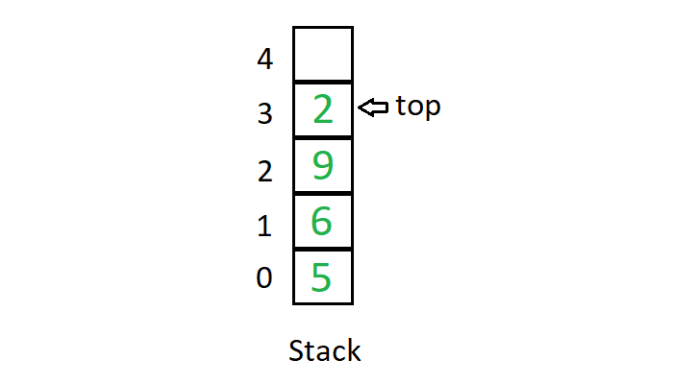

Mainly the following three basic operations are performed in the stack:

* **Push**: Adds an item in the stack. If the stack is full, then it is said to be an Overflow condition.
* **Pop**: Removes an item from the stack. The items are popped in the reversed order in which they are pushed. If the stack is empty, then it is said to be an Underflow condition.
* **Peek** or **Top**: Returns top element of the stack.
* **isEmpty**: Returns true if the stack is empty, else false.

Example to illustrate for stack: We’re going arrange the stack of books

Push operation: Now we put books one by one on the bookshelf.



Peek and Pop operations: Assumption that we want to take English book to read



1. Queue

Like Stack, Queue is a linear structure which follows a particular order in which the operations are performed. The order is First In First Out (FIFO).

A good example of the queue is any queue of consumers for a resource where the consumer that came first is served first.

The difference between stacks and queues is in removing. In a stack we remove the item the most recently added; in a queue, we remove the item the least recently added.

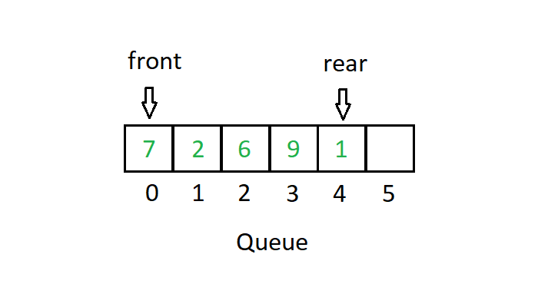

Mainly the following four basic operations are performed on queue:

* **Enqueue**: Adds an item to the queue. If the queue is full, then it is said to be an Overflow condition.
* **Dequeue**: Removes an item from the queue. The items are popped in the same order in which they are pushed. If the queue is empty, then it is said to be an Underflow condition.
* **Front**: Get the front item from the queue.
* **Rear**: Get the last item from the queue.



The image above is a real example of a queue, first come first served.

**Why Abstract Data Type became a necessity?**

* Earlier if a programmer wanted to read a file, the whole code was written to read the physical file device. So that is how Abstract Data Type (ADT) came into existence.
* The code to read a file was written and placed in a library and made available for everyone’s use. This concept of ADT is being used in the modern languages nowadays.

Topic 2: Analysis of Algorithms

### I. Introduction

* **What is an algorithm?**

An algorithm is the list of instructions and rules that a computer needs to do to complete a task.

Ex: Find the maximum value in array A

S1: Max ← A[0], i ← 0

S2: i ← i + 1

S3: If i > n, move to step 5

S4: If A[i] > Max, Max ← A[i], go back to step 2

S5: end.

* **Why performance analysis?**
* Algorithm analysis helps determine which algorithms are effective in terms of space and time, …
* When we work with large programs, we will have a good sense of where major slowdowns are likely to cause bottlenecks, and where more attention should be paid to get the largest improvements.

### II. Three cases to analyze an algorithm

Let us consider the following implementation of Linear Search



#### The Worst Case (O)

*In the worst case analysis, we calculate upper bound on running time of an algorithm. We must know the case that causes maximum number of operations to be executed.*

For *Linear Search*, the worst case happens when the element to be searched is not present in the array (x in the above code). When x is not present, the **search**() functions compare it with all the elements of arr[] one by one. Therefore, the worst case time complexity of linear search would be O(n).

#### The Average Case (Θ)

*In average case analysis, we take all possible inputs and calculate computing time for all the inputs. Sum all the calculated values and divide the sum by total number of inputs. We must know distribution of cases*.

For *Linear Search* problem, let us assume that all cases are uniformly distributed (including the case of x not being present in array). So we sum all the cases and divide the sum by (n+1).

$$\frac{\sum_{i=1}^{n+1}{θ(i)}}{n+1}= \frac{θ\left(\left(n+1\right)*\frac{n+2}{2}\right)}{n+1}= Θ(n)$$

#### The Best Case (Ω)

*In the best case analysis, we calculate lower bound on running time of an algorithm. We must know the case that causes minimum number of operations to be executed.*

In *Linear Search* problem, the best case occurs when x is present at the first location. The number of operations in the best case is constant (not dependent on n). So time complexity in the best case would be Θ(1).

Lower bound (Ω**)** ≤ Average time (Θ) ≤ Upper Bound (O)

Most of the times, we do worst case analysis to analyze algorithms. In the worst analysis, we guarantee an upper bound on the running time of an algorithm which is good information.

For insertion sort

|  |  |  |  |  |  |  |
| --- | --- | --- | --- | --- | --- | --- |
| *0* | *1* | *2* | *3* | *4* | *5* | *6* |
| 30 | 50 | 57 | 78 |  |  |  |

The worst case occurs when the array is reverse sorted. For example, when we add the number **10** into the array, all elements of the array move backward in one position.

The best case occurs when the array is sorted in the same order as output. For example, when we add the number **90** into the array without any change.

### III. Asymptotic Notations

#### Θ Notation



The **Theta** notation bounds a function from above and below, so it defines exact asymptotic behavior.

A simple way to get Theta notation of an expression is to drop low order terms and ignore leading constants.

For example, consider the following expression.

$$3n^{2}+n^{2}+4500= Θ(n^{3})$$

Θ(g(n)) = {f(n): there exist positive constants c1, c2 and n0

such that 0 ≤ c1*g(n) ≤ f(n) ≤ c2*g(n) for all n ≥ n0}

#### Notation:



The Big O notation defines an upper bound of an algorithm, it bounds a function only from above.

O(g(n)) = {f(n): there exist positive constants c and n0

such that 0 ≤ f(n) ≤ c*g(n) for all n ≥ n0}

For example, consider the case of Insertion Sort. It takes quadratic time in worst case. We can say that the time complexity of Insertion sort is O(n2).

#### Ω Notation



Just as Big O notation provides an asymptotic upper bound on a function, Ω notation provides an asymptotic lower bound.

Ω(g(n)) = {f(n): there exist positive constants c and n0

such that 0 ≤ c*g(n) ≤ f(n) for all n ≥ n0}

### IV. Properties of Asymptotic Notations:

Some important properties of those notations

1. **General properties:**

If f(n) is O(g(n)) then k*f(n) is also O(g(n)); where k is a constant.

Example: f(n) = 3n2 + 5 is O(n2)

Then we have 7*f(n) = 7(3n2 + 5) = 21n2 + 35 is also O(n2)

Similarly, this property satisfies for both Θ and Ω notation.

1. **Transitive properties:**

If f(n) is O(g(n)) and g(n) is O(h(n)) then f(n) = O(h(n))

Example: if f(n) = n, g(n) = n2 and h(n) = n3

n is O(n2) and n2 is O(n3) then n is O(n3)

Similarly, this property satisfies for both Θ and Ω notation.

1. **Reflexive properties:**

If f(n) is given, then f(n) is O(f(n)). Since max value of f(n) will be f(n) itself.

Example: f(n) = n2; O(n2) that is O(f(n))

Similarly, this property satisfies for both Θ and Ω notation.

1. **Symmetric properties:**

If f(n) is Θ(g(n)) then g(n) is Θ(f(n))

Example: f(n) = n2 and g(n) = n2

then f(n) = Θ(n2) and g(n) = Θ(n2)

This property only satisfies for Θ notation.

1. **Transpose Symmetric Properties**

If f(n) is O(g(n)) then g(n) is Ω(f(n))

Example: f(n) = n, g(n) = n2

then n is O(n2) and n2 is Ω(n)

This property only satisfies for O and Ω notations.

Topic 3: Search Algotithms

## Lesson 1: Basic search algorithm

### I. Introduction.

* Searching algorithms are designed to check for an element or retrieve an element from any data structure where it is stored.
* Based on the type of search operation, these algorithms are generally classified into two categories:
  + ***Sequential search***.
  + ***Interval search***.
* Depend on the case of the data to use the right one of the two algorithms above.
* To be easier for illustration, the object that contains a individual that we are going to search in this topic is the a consecutive sequence of integers (array of integers)
* There are also different methods to search for a element like *Hashing* or using *Search Trees* which also will be researched deeper in different topics.

### II. Search Algorithms.

#### Liner search. (Sequential search)

* This is the simplest method to searching for an element.
* The array is tranversed through every single element while making a comparison between the current element in the array with the element we are looking for.
* Time Complexity: O(n).
* Example:

Array A = {**84**, **65**, **148**, **1**, **49**, **26**}.

* Search for the key = 148:



Example 1 - 1

* Search for key = 0:



Example 1 - 2

* Advantage: Easy to implement.
* Disadvantage: Take very long time.

#### Binary search. (*Interval search)*

* This algorithm is only able to be used on sorted structures.
* The main action of this algorithm is the division half of the current’s total of elements by eliminating all the elements before or after the middle element depend on what value of the element is looking for and the middle element is considering in the current elements.
* Time Complexity: O(log n).
* Example:

Array A = {**84**, **65**, **148**, **1**, **49**, **26**}.

* Search for the key = 148:



Example 2 - 1

* Search for the key = 55:



Example 2 - 2

## Lesson 2: Hashing

### I. Introduction

Suppose that we want to design a system for storing student records keyed using Student ID and we want following queries to be performed efficiently:

1. Insert a Student ID and corresponding information.

2. Search a Student ID and fetch the information.

3. Delete a Student ID and related information.

For example, to insert a Student ID, we create a record with details of given Student ID, use Student ID as index and store the pointer to the created record in table. But this solution has many practical limitations. The problem with this solution is extra space required is huge. For example, in my university, the student ID has 8 digits, we need O(m * 108) space for table where m is size of pointer to record. So, hashing appeared to solve this problem.

*Hashing* is the solution that can be used in almost all such situations and performs extremely well compared to data structures like Array, Linked List, … in practice. With hashing we get O(1) search time on average and O(n) in worst case.

Hash function:

The idea is to use hash function that converts a given big number or string to a smaller integer and uses the small number as index in a table called hash table.

A good hash function should have following properties:

1. Efficiently computable.

2. Should uniformly distribute the keys.

Hash Table:

An array that stores the pointers to records corresponding to a given element.

Collision Handling:

Since a hash function gets us a small number for a big key, there is possibility that two keys result in same value. The situation where a newly inserted key maps to an already occupied slot in hash table is called *collision* and must be handled using some collision handling technique. We are going to discuss them in part II, III.

### II. Separate Chaining

The idea is to make each cell of hash table point to a linked list of records that have same hash function value.

Let us consider a simple hash function as “**key mod 7**” and sequence of keys as 101, 693, 57, 84, 94, 73.



Advantages:

1. Simple to implement.

2. Hash table never fills up, we can always add more elements to the chain.

3. It is mostly used when it is unknown how many keys may be inserted or deleted.

Disadvantages:

1. Cache performance of chaining is not good as keys are stored using a linked list.

2. Wastage of Space (Some Parts of hash table are never used).

3. If the chain becomes long, then search time can become O(n) in the worst case.

4. Uses extra space for links.

### III. Open Addressing

Open addressing is also a method for handling collisions. In this method, all elements are stored in the hash table itself. So, at any point, the size of the table must be greater than or equal to the total number of keys.

The idea of Open Addressing:

* Insert(k): Keep probing until an empty slot is found. After an empty slot is found, insert k.
* Search(k): Keep probing until slot’s key doesn’t become equal to k or an empty slot is reached.
* Delete(k): If we simply delete a key, then the search may fail. So, slots of deleted keys are marked specially as “deleted”. The insert can insert an item in a deleted slot, but the search doesn’t stop at a deleted slot.

#### Linear probing

If the current position has been taken, we will find another position. In linear probing, we linearly probe for next slot.

h (k, i) = (hash(k) + i) mod S

Where:

i is the order of the attempt (i = 0, 1, 2, …)

hash(k): hash function

S: size of the array

Let **hash(x)** be the slot index computed using a *hash function* and **S** be the table size:

If slot [hash(x) % S] is full, then we try [(hash(x) + 1) % S]

If [(hash(x) + 1) % S] is also full, then we try [(hash(x) + 2) % S]

If [(hash(x) + 2) % S] is also full, then we try [(hash(x) + 3) % S]

……………………………………………………………………

Let us consider a simple hash function as “**key mod 7**” and a sequence of keys as 50, 700, 76, 85, 92.



Some problems with **Linear Probing**:

1. Many consecutive elements form groups, and it starts taking time to find a free slot or to search for an element.

2. Two records only have the same collision chain if their initial position is the same.

#### Quadratic Probing

Like linear probing, but we use quadratic function.

h (k, i) = (hash(k) + i2) mod S

Where:

i: the order of the attempt (i = 0, 1, 2, …)

hash(k): hash function

S: size of the array

Let **hash(x)** be the slot index computed using hash function.

If slot [hash(x) % S] is full, then we try [(hash(x) + 1 * 1) % S]

If [(hash(x) + 1 * 1) % S] is also full, then we try [(hash(x) + 2 * 2) % S]

If [(hash(x) + 2 * 2) % S] is also full, then we try [(hash(x) + 3 * 3) % S]

……………………………………………………………………………

Let us consider a simple hash function as “**key mod 7**” and a sequence of keys as 76, 40, 48, 5, 55.



#### Double Hashing

Double hashing uses the idea of applying a second hash function to key when a collision occurs.

h (k, i) = (hash1(k) + i* hash2(k)) mod S

Where:

i: the order of the attempt (i = 0, 1, 2, …)

hash1(k) and hash2(k): hash functions

S: size of the array

let hash(x) be the slot index computed using hash function.

If slot [hash(x) % S] is full, then we try [(hash(x) + 1*hash2(x)) % S]

If [(hash(x) + 1*hash2(x)) % S] is also full, then we try [(hash(x) + 2*hash2(x)) % S]

If [(hash(x) + 2*hash2(x)) % S] is also full, then we try [(hash(x) + 3*hash2(x)) % S]

.......................................................................................................................................

First hash function is typically hash1(k) = k % S

A popular second hash function is: hash2(k) = PRIME – (k % PRIME) where PRIME is a prime smaller than the TABLE_SIZE.

A good second Hash function is:

* It must never evaluate to zero.
* Must make sure that all cells can be probed.

Let us consider 2 simple hash functions as “**key mod 13**” and “**key mod 7**”, and a sequence of keys as 19, 27, 36, 10.



Topic 4: Sort Algorithms

### I. Introduction.

* Sorting algorithms are used in many data structures and applications to reorder the members of the list based on the comparison between elements.
* There are a variety of different sorting algorithms which will come with different time and space complexity and depend on the case of the data to use the suitable sorting algorithm for it.
* To be easier for illustration, the structure that we are going to sort in this topic is a consecutive sequence of integers (array of integers)
* They can also be classified in many ways like in-place, recursion, non-recursion, stability, …

### II. Sort Algorithms.

#### Selection Sort.

* Selection Sort proceeds by finding the smallest (or largest, depending on sorting order) element in the right unsorted subarray, exchanging it with the leftmost unsorted element (putting it in sorted order), and expand the sublist boundaries one element to the right.
* Selection sort is an in-place comparison sorting algorithm.
* Time Complexity: O(n2)
* Advantages:
  + It takes the elements to their final positions in the sorted array.
  + Selection sort is typically used in situations where the auxiliary memory is limited because it is a in-place sorting algorithm.
  + Easy to implement.
* Disadvantages: High time complexity.
* Example:

Array A = {**84**, **65**, **148**, **1**, **49**, **26**}.

Sort in ascending order:



Example 1 - 1

Sort in descending order:



Example 1 - 2

Array B = {**1, -678, 952, -357, -711**}.

Sort in ascending order:



Example 1 - 3

#### Insertion Sort.

* Insertion Sort is a simple sorting algorithm. The array is virtually split into a sorted and an unsorted part. Values from the unsorted part are picked and placed at the correct position in the sorted part by making some comparisons: if the element is smaller than its predecessor, compare it with the elements before. Move the greater elements one position up to make space for the swapped element.
* Insertion Sort is an in-place and stable comparison sorting algorithm.
* Advantages:
  + Real-time sorting, data may be incomplete or coming, but the array is still sortable.
  + Efficient for small data sets, much like other quadratic sorting algorithms and more efficient than most other simple quadratic algorithms such as *Selection Sort* or *Bubble Sort*
  + Easy to implement.
* Disadvantages:
  + High time complexity.
  + It is much less efficient on large lists than more advanced algorithms such as *Quick Sort*, *Heap Sort*, or *Merge Sort*.
* Example:

Array A = {**84**, **65**, **148**, **1**, **49**, **26**}.

Sort in ascending order:



Example 2 - 1

Sort in descending order:



Example 2 - 2

Array B = {**1, -678, 952, -357, -711**}.

Sort in descending order:



Example 2 - 3

#### Binary Insertion Sort.

* Binary insertion Sort is a variant of the *Insertion Sort*. Because of finding the insert position is sequential in *Insertion Sort*. For a better way, we use the *Binary Search* method to find this position.
* Binary insertion Sort employs a binary search to determine the correct location to insert new elements, and therefore performs O(log2n) comparisons in the worst case. When each element in the array is searched for and inserted this is O(nlogn).
* But because of the series of swaps required for each insertion. The algorithm as a whole still has a time complexity of O(n2) on average.
* Advantages: The number of swaps is reduced more than a normal *Insertion Sort*.
* Example:

Array A = {**84**, **65**, **148**, **1**, **49**, **26**}.

Sort in ascending order:



Example 3 - 1

Sort in ascending order:



Example 3 - 2

Array B = {**1, -678, 952, -357, -711**}.

Sort in ascending order:



Example 3 - 3

#### Interchange Sort.

* Interchange Sort works by comparing the first element with all elements behind it, swapping where needed, it then proceeds to do the same for the second element, and so on.
* Interchange Sort is an in-place comparison sort.
* Time complexity: O(n2)
* Advantages:
  + Like any simple O(n2) sort it can be reasonably fast over very small data sets, though in general insertion sort will be faster.
  + Easy to implement.
* Disadvantages:
  + High time complexity.
  + It is much less efficient on large lists.
* Example:

Array A = {**84**, **65**, **148**, **1**, **49**, **26**}.

Sort in ascending order:



Example 4 - 1

Sort in descending order:



Example 4 - 2

Array B = {**1, -678, 952, -357, -711**}.

Sort in descending order:



Example 4 - 3

#### Bubble Sort.

* Bubble Sort is a simple sorting algorithm that repeatedly steps through the list, compares adjacent elements, and swaps them if they are in the wrong order. The pass through the list is repeated until the list is sorted.
* Bubble Sort is an in-place comparison sort.
* Time complexity: O(n2)
* Advantages:
  + Easy to implement.
* Disadvantages:
  + High time complexity.
  + It is much less efficient on large lists.
* Example:

Array A = {**84**, **65**, **148**, **1**, **49**, **26**}.

Sort in ascending order:



Example 5 - 1

Sort in descending order:



Example 5 - 2

Array B = {**1, -678, 952, -357, -711**}.

Sort in descending order:



Example 5 - 3

#### Shaker Sort.

* Shaker Sort is an extension of *Bubble Sort*.
* The algorithm extends *Bubble Sort* by operating in two directions. While it improves on *Bubble Sort* by more quickly moving items to the beginning of the list.
* Shaker Sort is an in-place comparison sort.
* Time complexity: O(n2)
* Advantages:
  + If the list is mostly ordered before applying the sorting algorithm it becomes closer to O(n) time complexity.
* Disadvantages:
  + High time complexity.
  + It is much less efficient on large lists.
  + Even it is an extension of *Bubble Sort* but it still not be better than *Insertion Sort.*
* Example:

Array A = {**84**, **65**, **148**, **1**, **49**, **26**}.

Sort in ascending order:



Example 6 - 1.1



Example 6 - 1.2

Sort in descending order:



Example 6 – 2.1



Example 6 – 2.2

Array B = {**1, -678, 952, -357, -711**}.

Sort in descending order:



Example 6 – 3

#### Shell Sort.

* Shell Sort is a modified version of *Insertion Sort* that allows the exchange of items that are far apart.
* The sorting algorithm compares elements separated and using *Insertion Sort* methods but by a distance and decreases on each pass.
* Shell Sort is an in-place comparison sort.
* Time complexity: O(n2)
* Advantages:
  + Shell Sort has distinctly improved running times more than *Insertion Sort.*
* Example:

**Note that: You can freely choose the distance apart of the elements (**gap**). In these examples, The **gap** will start with **n/3** and will be reduced by dividing it by **2** in each pass.

Array A = {**84**, **65**, **148**, **1**, **49**, **26**}.

Sort in ascending order:



Example 7 - 1.1



Example 7 - 1.2

Sort in descending order:



Example 7 - 2.1



Example 7 – 2.2

Array B = {**1, -678, 952, -357, -711**}.

Sort in ascending order:



Example 7 - 3

#### Heap Sort.

* Heap Sort divides its input into a sorted and an unsorted region, and it iteratively shrinks the unsorted region by extracting the largest element from it and inserting it into the sorted region.
* The concept of it seems like it is very similar with *Selection Sort*, but Heap Sort does not waste time with a linear-time scan of the unsorted region. Rather, Heap Sort maintains the unsorted region in a *Heap Data Structure* or *Binary Heap* to more quickly find the largest element in each step.
* A *Binary Heap* is a complete *Binary Tree* where items are stored in a special order such that the value in a parent node is greater(or smaller) than the values in its two children nodes. The former is called *Max Heap* and the latter is called *Min Heap*. The heap can be represented by a binary tree or array.
* Heap sort is an in-place comparison sorting algorithm, but it is not a stable sort.
* Time complexity: O(nlogn)
* Advantages:
  + Low time complexity.
* Disadventages:
  + The implementation of the *Quick Sort* is still better.
* Example:

Array A = {**84**, **65**, **148**, **1**, **49**, **26**}.

Sort in ascending order:



Example 8 - 1.1



Example 8 – 1.2

Sort in descending order:



Example 8 - 2.1



Example 8 – 2.2

Array B = {**1, -678, 952, -357, -711**}.

Sort in ascending order:



Example 8 - 3

#### Quick Sort.

* It works by selecting a 'pivot' element from the array and partitioning the other elements into two sub-arrays, according to whether they are less than or greater than the pivot. The sub-arrays are then sorted recursively. This can be done in-place.
* Quick Sort is an in-place and unstable sorting algorithm and also is a divide and conquer algorithm.
* Time complexity: O(nlogn)
* Advantages:
  + Low time complexity. Faster than *Merge Sort* and about 2 or 3 times faster than *Heap Sort*.
* Disadventages:
  + Requiring small additional amounts of memory to perform the sorting.
* Example:

Array A = {**84**, **65**, **148**, **1**, **49**, **26**}.

Sort in ascending order:



Example 9 - 1

Sort in descending order:



Example 9 - 2

Array B = {**1, -678, 952, -357, -711**}.

Sort in descending order:



Example 9 - 3

#### Merge Sort.

* Merge Sort repeatedly breaks down a list into several sublists until each sublist consists of a single element and merging those sublists in a manner that results into a sorted list.
* Merge Sort is an in-place and stable comparison sorting algorithm and also is a divide and conquer algorithm.
* Time complexity: O(nlogn)
* Advantages:
  + Low time complexity.
* Disadventages:
  + Requiring small additional amounts of memory to perform the sorting.
  + Goes through the whole process even if the list is sorted.
* Example:

Array A = {**84**, **65**, **148**, **1**, **49**, **26**}.

#### Radix Sort.

* The idea of Radix Sort is to do digit by digit sort starting from least significant digit to most significant digit.
* Radix Sort is a non-comparative stable sorting algorithm. It avoids comparison by creating and distributing elements into buckets according to their radix.
* Time complexity: O(n*k) (k is the length of the data)
* Advantages:
  + Fast when the keys are short or when the range of the array elements is less.
* Disadvantages:
  + Since Radix Sort depends on digits or letters, Radix Sort is much less flexible than other sorts. So, for every different type of data it needs to be rewritten.
  + It takes more space compared to *Quick Sort* which is inplace sorting.
* Example:

Array A = {**84**, **65**, **148**, **1**, **49**, **26**}.

### III. Applications.

Topic 5: Tree

## Lession 1: Tree

**Contents:**

* **Introduce**
* **Properties of Tree**

### I. Introduction:

* A tree <T> (Tree) is:

+A set of values ​​of the same type, elements of the same value are stored by a node, called node p1, p2, ...

+ If a tree has no elements, it is called an empty tree.

+If the tree is not empty, there are some caveats:

* Each tree has only 1 root node. The root node is the starting node of the tree.

* The remaining nodes are divided into non-intersection sets (Ti ,Ti+1,…). Each <Ti> is called a subtree of <T> tree. Example:

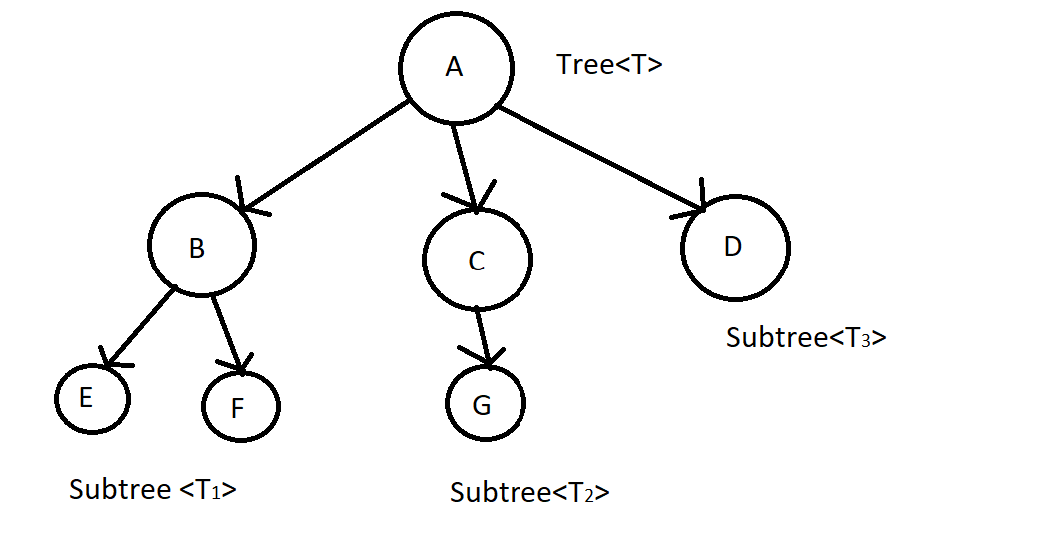

### II. Properties of Tree:

+The root node has no parent node.

+Leaf node (external node):is a node that does not have any child nodes.

+ Parent node: is the node that we will be processed to do something before reaching another node that it can go to. Child node: It is the node that when the parent node has been processed, it comes to it. Example:

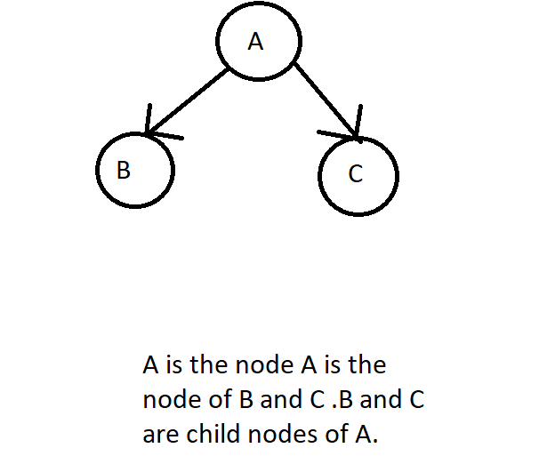

+Each node has only one node parent.

+Each node can have multiple children.

+Trees do not count cycles. That is, when a node 1 node goes to a child node, the child node cannot have any path in the tree to go against the node above. If possible, it is called a graph.

+Node: is an element in tree. Node can contain any data. Each node can contain many types of data. For example, 1 node can contain 1 data as name, another data as age, ... And importantly, all nodes must be the same in terms of data but may differ in the values ​​in the data that the node holds. That's why we say a tree is a data structure that collects elements of the same type.

+Branch: link 2 nodes together.

+ Sibling nodes: is a node with the same parent node.

+Degree of node: number of children of a node.

+Internal node: is a node that has both a parent node and a child node.

+Subtree: is a subtree of the original tree. Also starts with a node.

+Degree of tree is the maximum value of the degree of node in the tree. When we interpret it with a formula, we can write:

Degree (<T>) = max {degree (pi) / pi ∈ <T>}

Example:

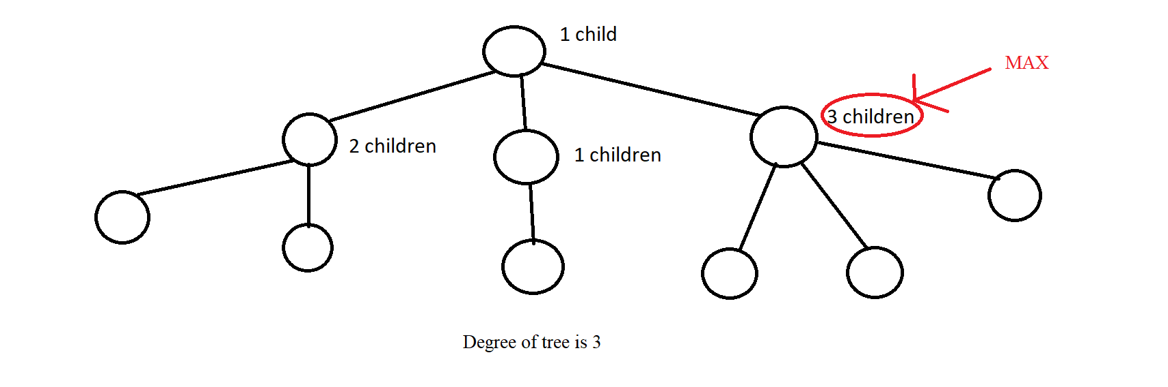

+Path between node pi to node pj: is a series of nodes from pi to pj and on those nodes there must be branches to connect 2 nodes together. Example:

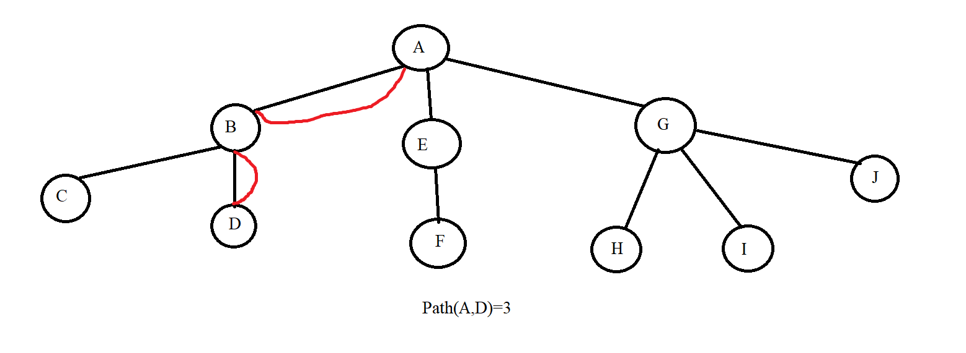

+Level: Just like how to calculate the floor of a whole tower, we apply it to trees as well. Where the ground floor is the root with level =0 and the upper floors are considered the bottom nodes of a node, the level is calculated as the parent node's level plus 1. From this we can deduce the formula:

Level(p) = 0 if p = root

Level(p) = 1 + level(parent(p)) if p! = Root

Example:

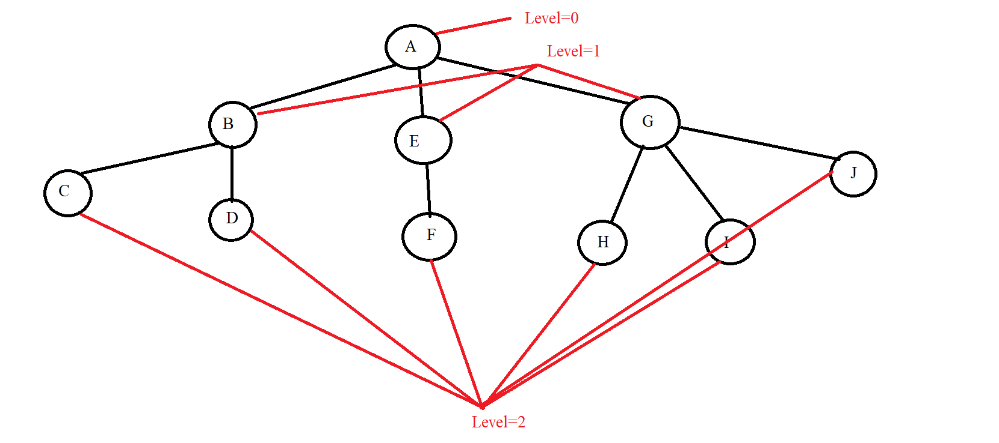

+Height of tree (hT): Maximum value of path from root to leaf node. We have the mathematical formula:

hT = max {Path (root, pi) | pi is the leaf node ∈ <T>}

Example:

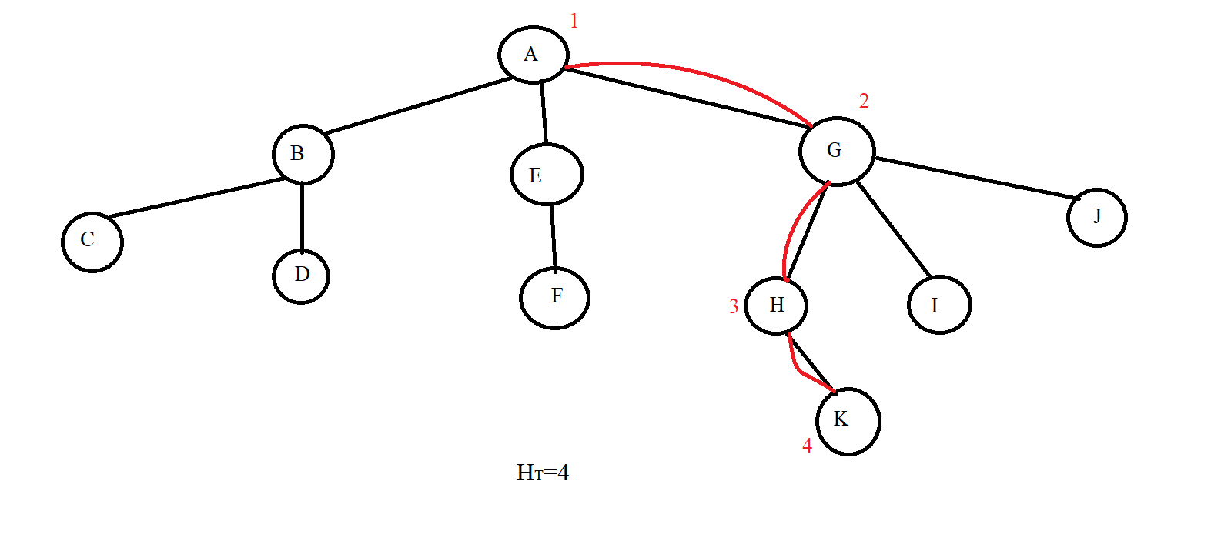

## Lession 2: Binary tree

**Contents:**

* **Introduction**
* **Operations on Binary Tree**

### I. Introduction

*A tree <T> (Tree) is a binary tree when the degree of the tree is 2.

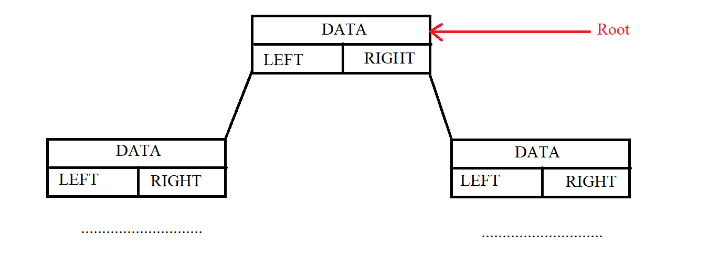

*The height of a binary tree has N nodes:

hT(max) = N

hT(min) = $\log_{2}{N}$ + 1

Example: with N=4

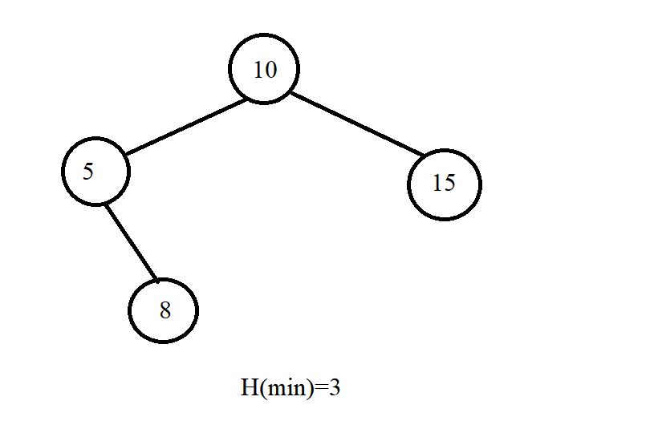

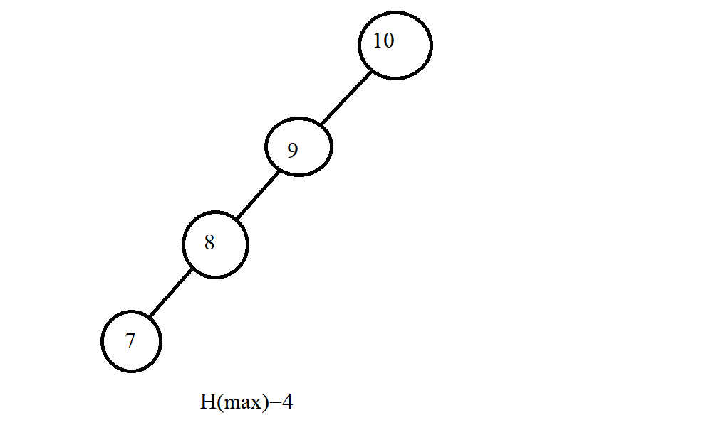

*There are 2 ways to organize a binary tree:

+Array.

+ Structure pointers.

* Here it is best to use pointers because it is easier to use pointers to delete, insert and search. Pointers make it easier to know the child node of a node.



### II. Operations on Binary Tree

*Traverse in Tree: We have many ways of traversing such as NLR, LRN, RNL, ... but we only consider 3 basic traversals: NLR, LRN and LRN.

+ Pre-Order (NLR): It will process the current node and then recursively call the left node and finally the right node. Put the case we want in the buttons in we have the following examples

|  |
| --- |
|  |

Example:

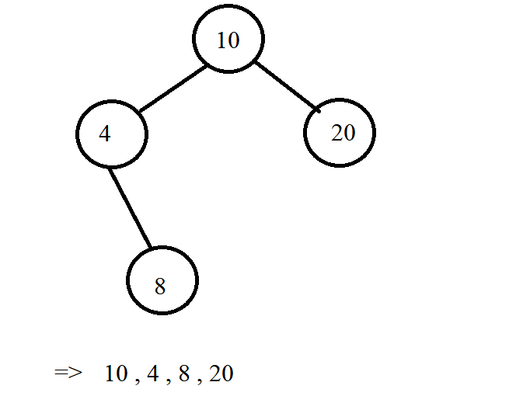

+ In-Order (LNR): It will recursively call the left node. Then it will process the current node and finally recursively call the right node.



Example:

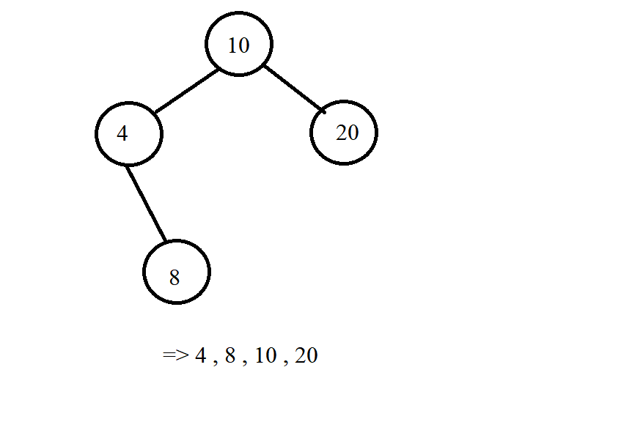

+Post-Order (LRN): We will recursively call the left node, go to the right node and finally process the current node.



Example:

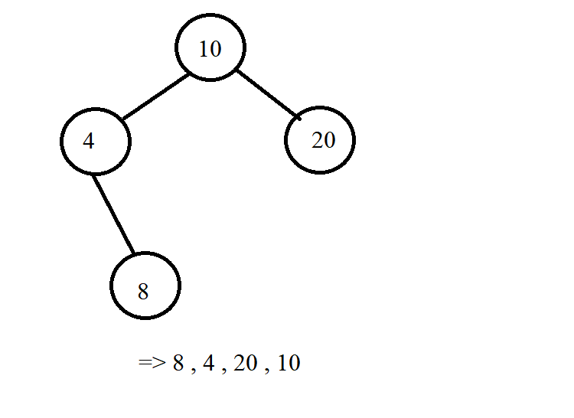

*\*Note*: In addition to printing nodes like the examples above, we can change the place (cout<< pCurr->Data << " ") to whatever command we want to handle the query, the subject we want. Below is an illustration of the traversal of the three methods above.







## Lession 3: Binary search tree (BST)

**Contents:**

* **Introduction**
* **Operations on Binary Search Tree**
* **Illustration examples**

### I. Introduction

**-** The binary search tree is:

+A binary tree: That is, each node has at most 2 child nodes.

+Each value node exists only once in the tree.

+ Each node must satisfy the condition:

. All nodes of the left subtree must be less than the current node.

. All nodes of the right subtree must be less than the current node.

. Assuming the current node is node (p), then we have:

∀L ∈ p-> pLeft: L-> Data <p-> Data

∀R ∈ p-> pRight: R-> Data> p-> Data

Example:

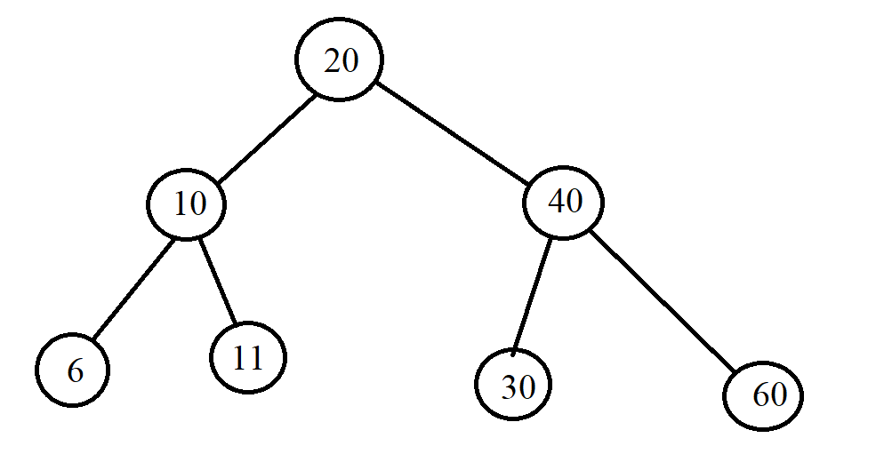

### II. Operations on Binary Search Tree:

+ Create an empty tree.



+ Check the empty tree.



+Find an element: Using the same condition for each node in the BST that the left child is less than the current node and the right node is greater than the current node, we will apply it to finding the element in the BST tree. Accordingly, if the current node that the tree is traversing has data larger than the element we are looking for, we will recursively go to the left node and vice versa, we will recursively go to the right. If we find the value we want to find, we stop and if we can't find it, the node is Null. Example:

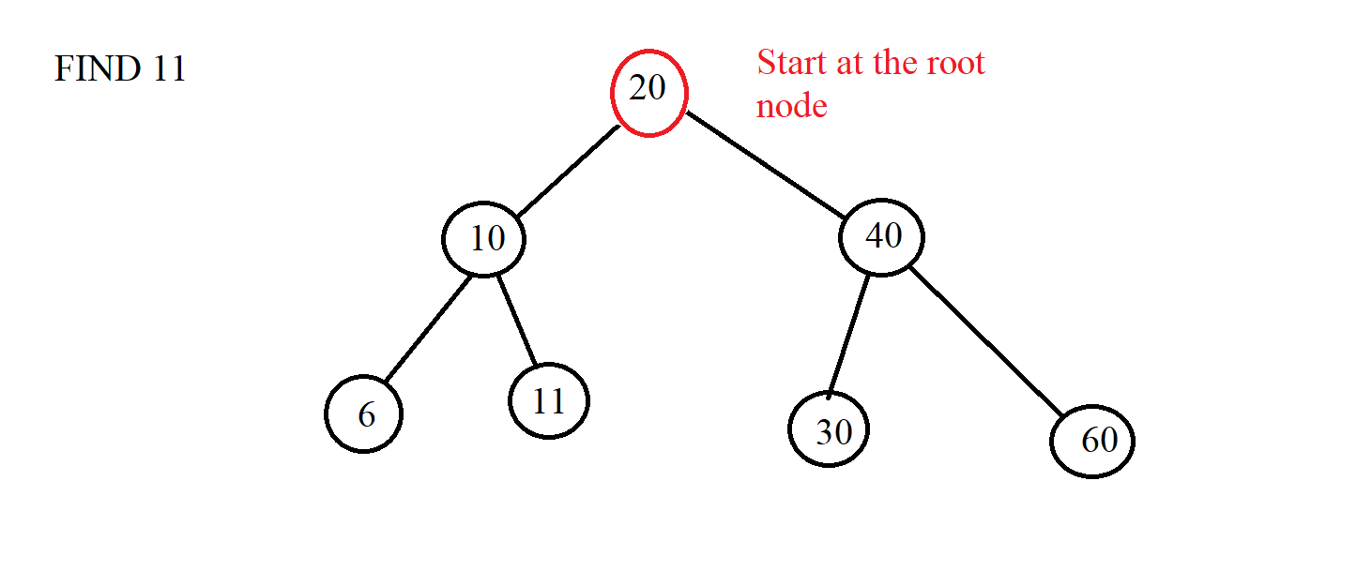

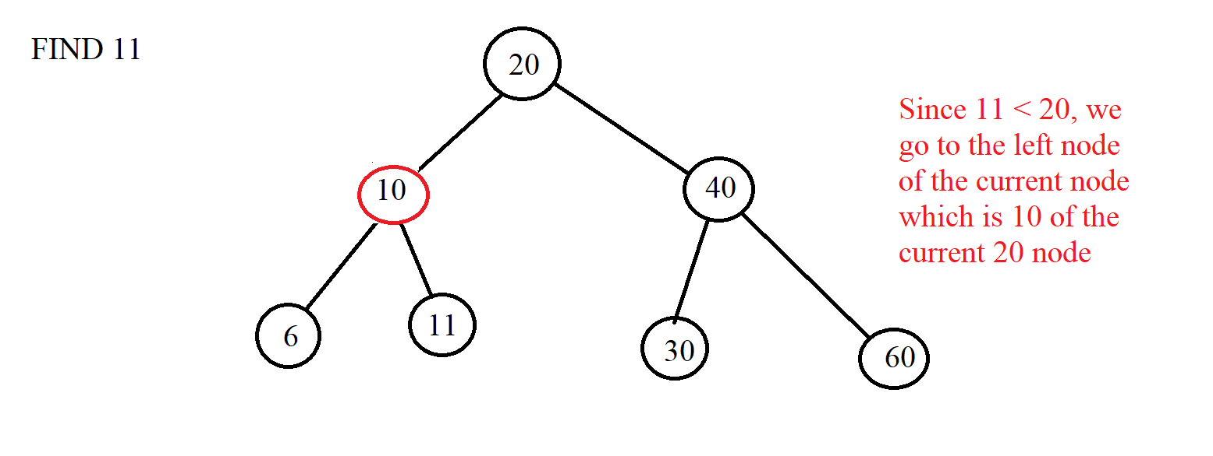

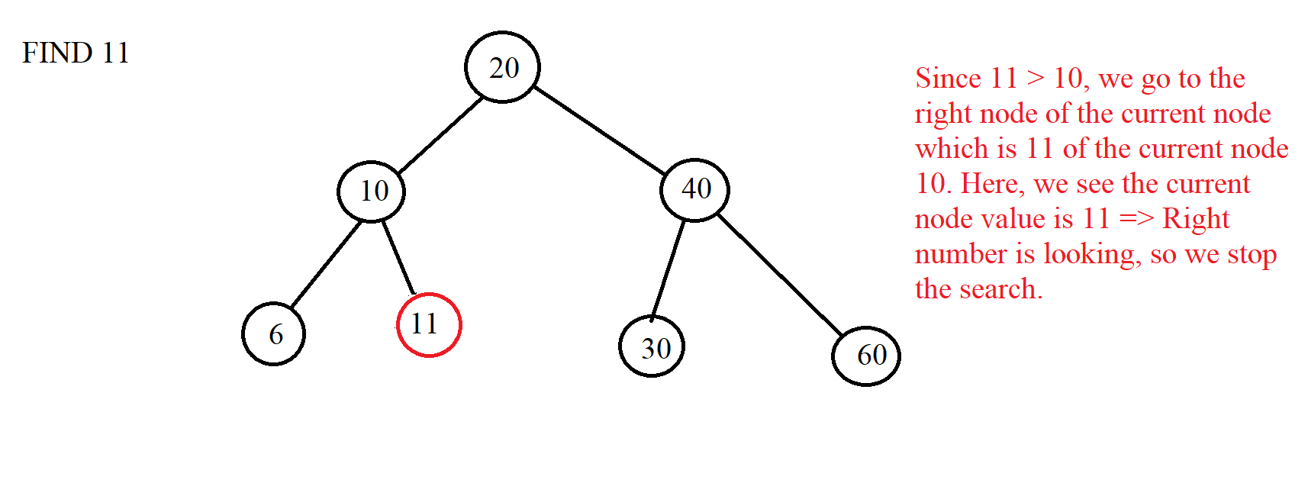



+ Add 1 element: Just like the search is based on conditions, we will start at the root node and will traverse left if the inserted element is greater than the current node and vice versa. We will do this until the current node is a NULL node and finally, we replace the NULL node with the node that we initialize with the value we want to insert.

Example:

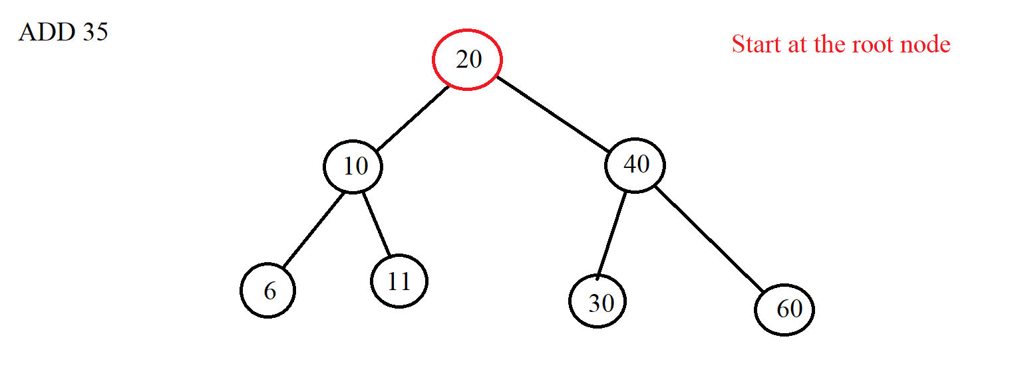

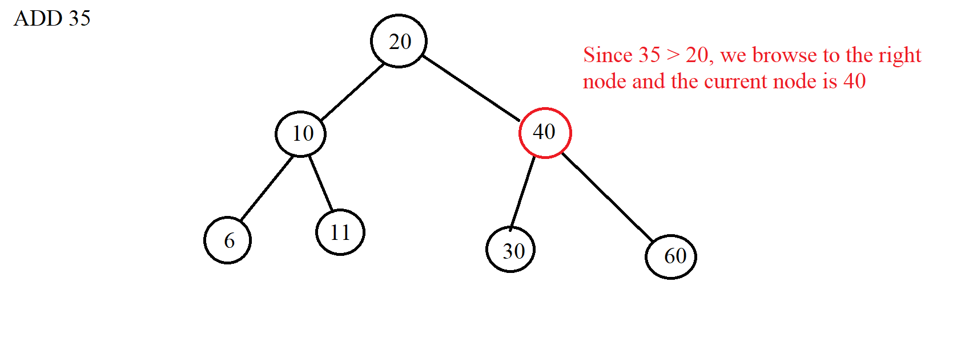

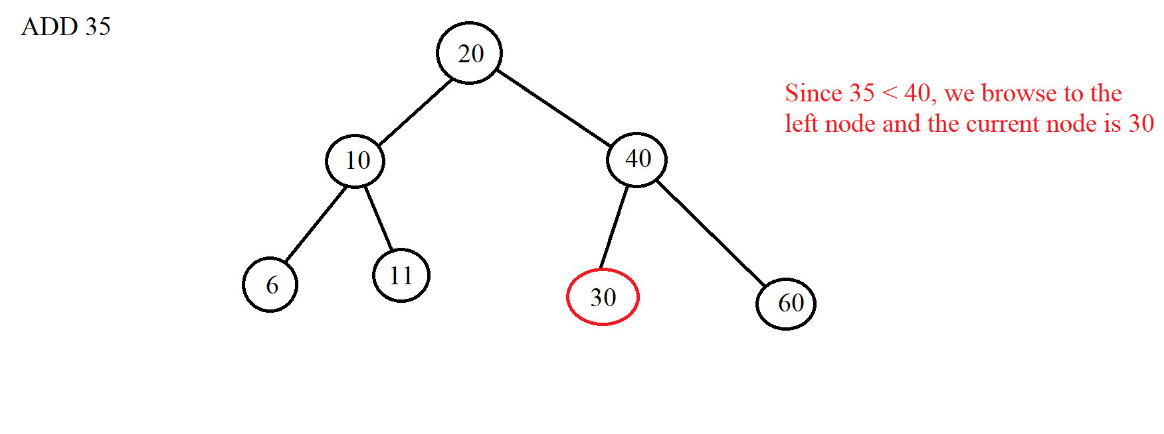

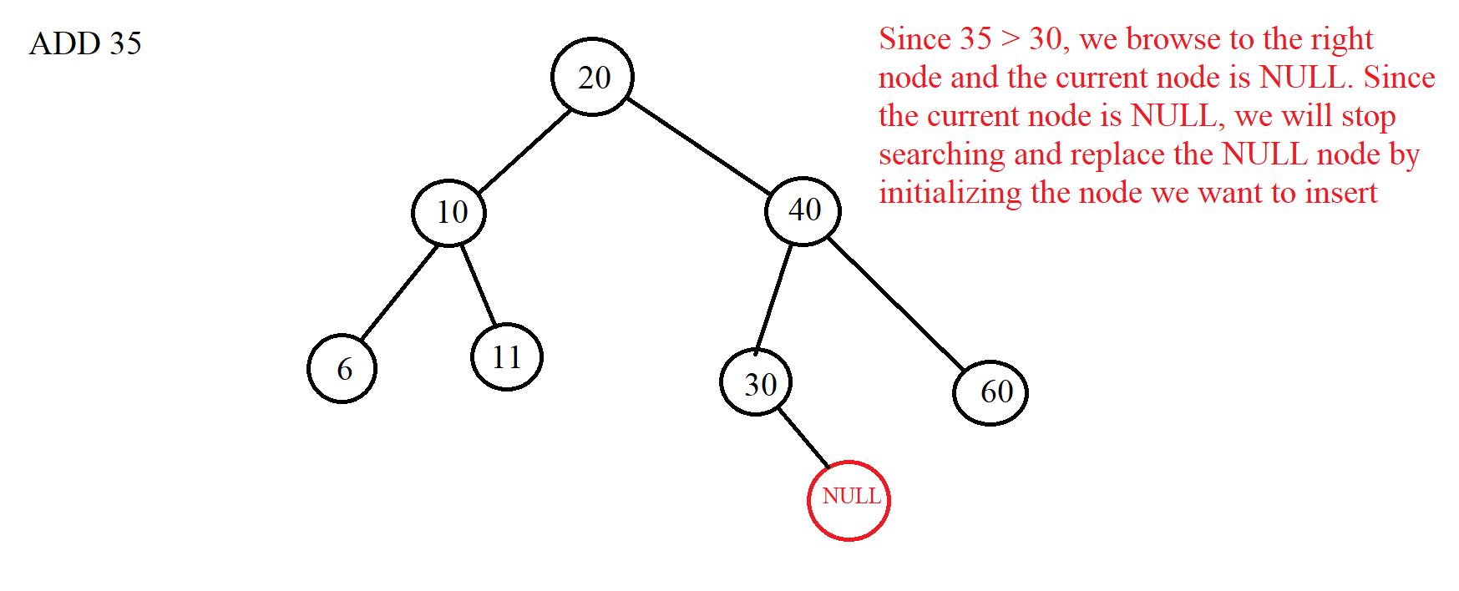

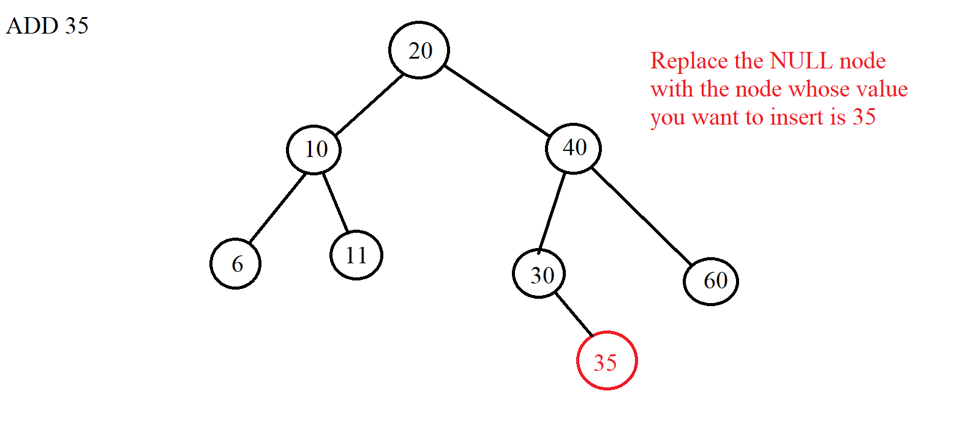



+ Delete 1 element: We use the above tree search algorithm to find the element we want to delete. If you can't find it, it means there is no element in the tree. And if there is, then we divide into 3 cases to delete.

***Case 1***: Delete node without any child node => We just need to delete that node and let the parent node of the node to be deleted connect to the NULL node. Example:

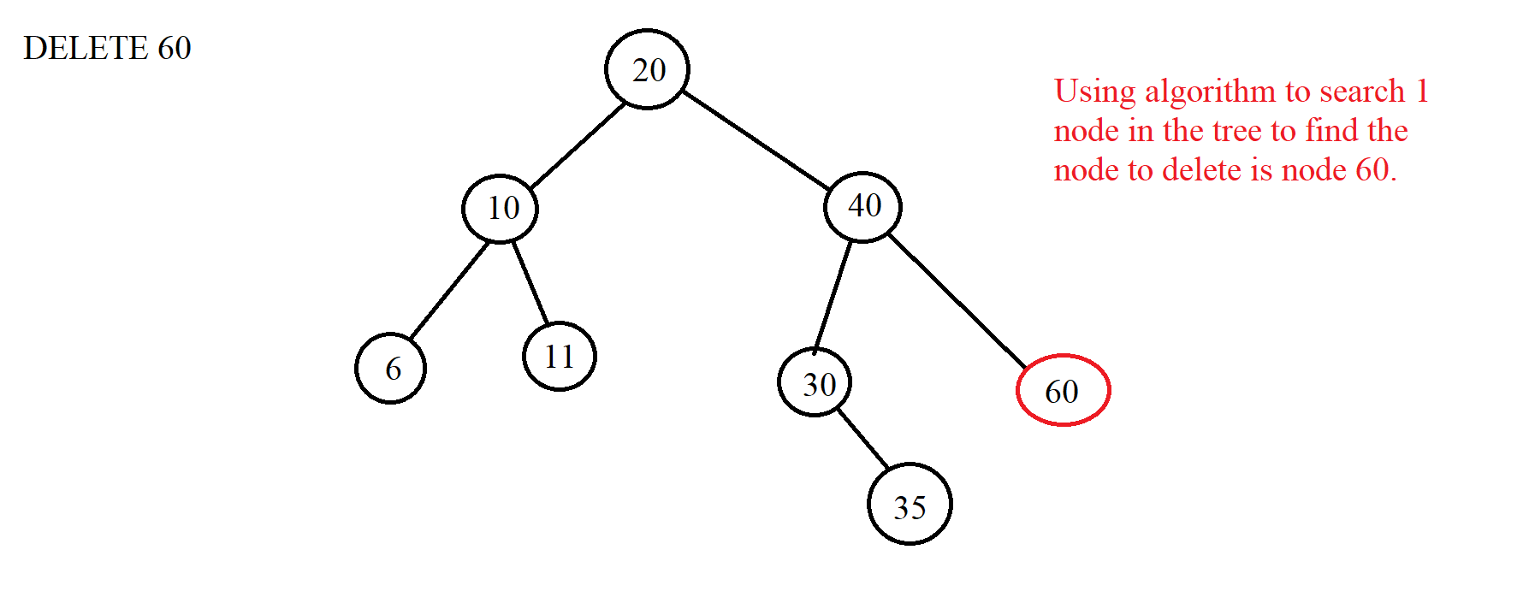

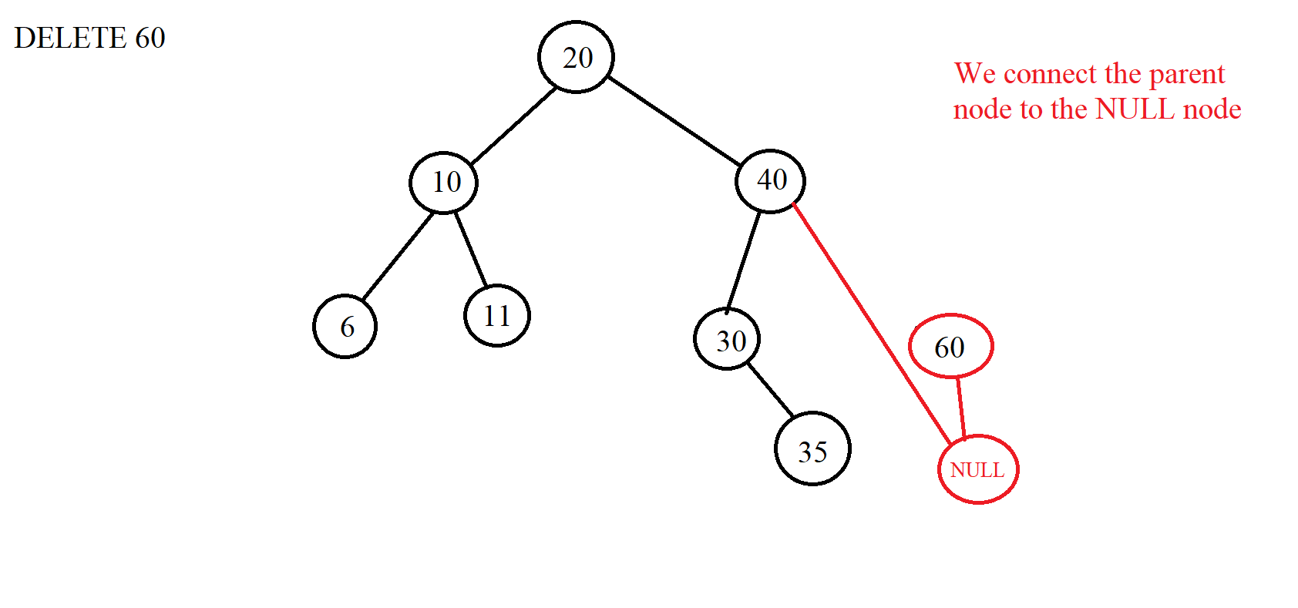

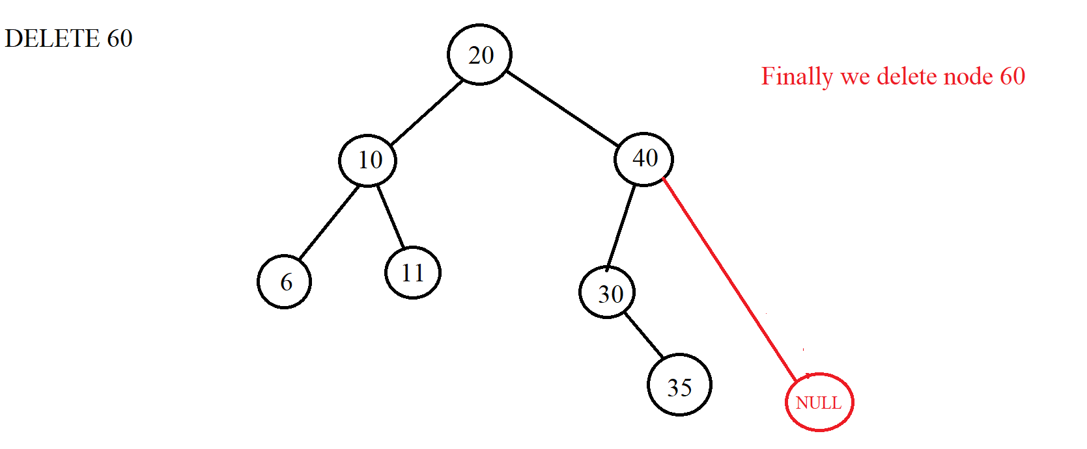

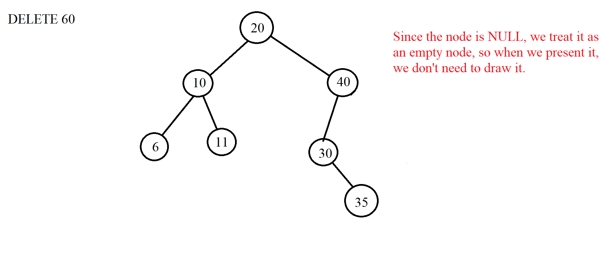

***Case 2***: Delete node with 1 child node => When we want to delete the element to be deleted in this case, we must connect the parent node of the node to be deleted with the child node of that node because that way the new tree will not be broken. When the connection is complete, we just need to delete it. When connecting the parent node of the node to be deleted with its child, we need to pay attention that if the left child node of that node is a NULL node, we will connect to the right child node and vice versa. In fact, this case is similar to case 1, but only the difference is that a child node is NULL and here is a valid node. Example we delete node 30 with 35 as the right child:

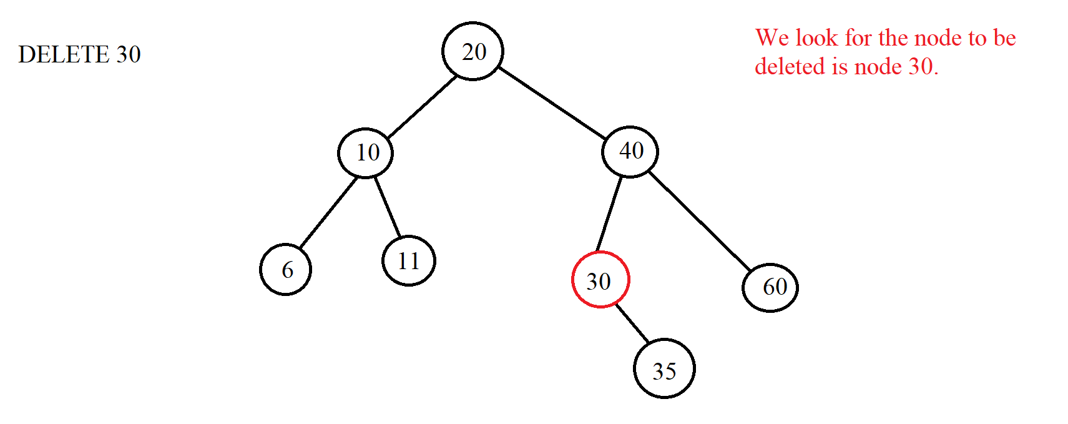

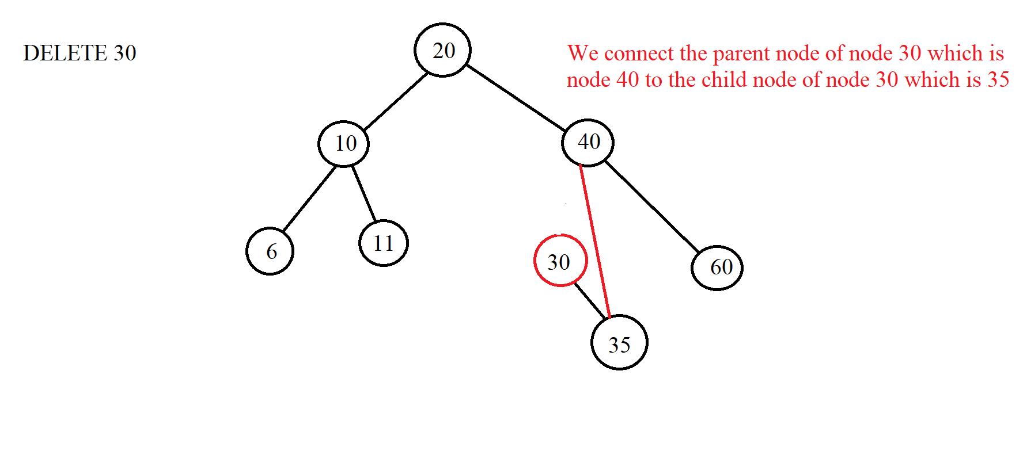

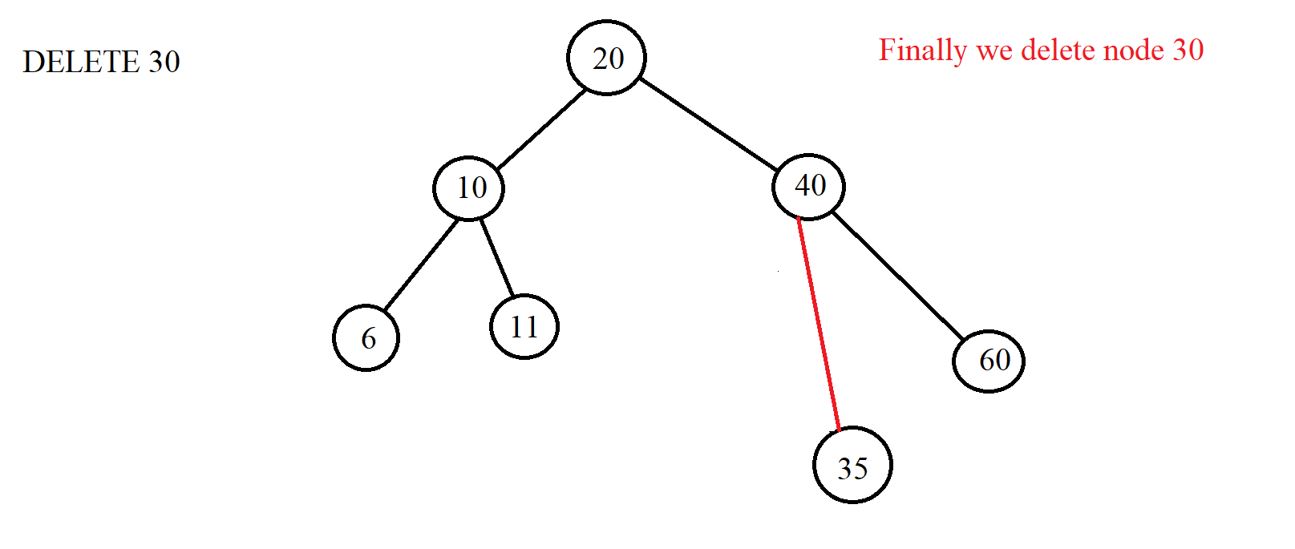

Similarly, when we delete 30 and 25 are left child nodes:

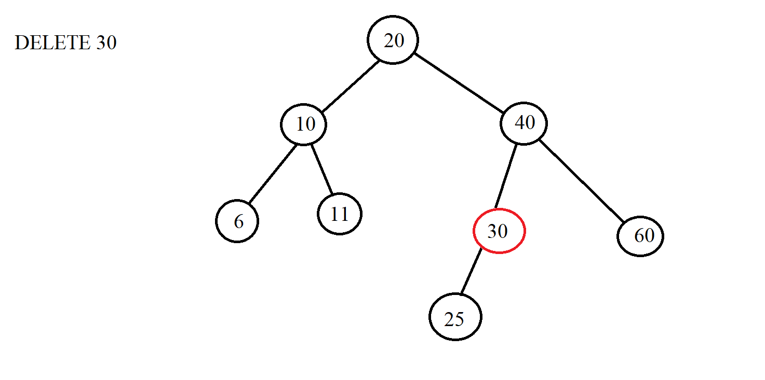

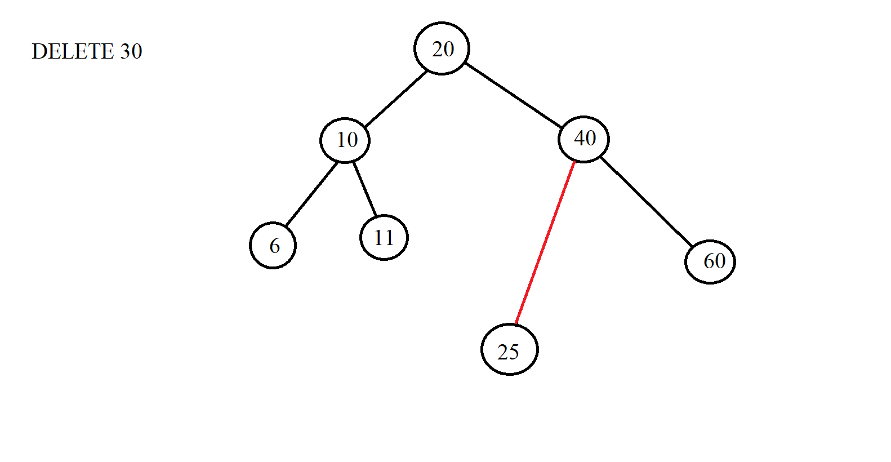***Case 3***: Delete node with 2 children => Instead of deleting that node, we delete the node for which we get the value to replace the node that needs to be deleted. Then the node that we want to delete will be replaced with another value. Therefore, the node so that we can substitute the value for the node we want to delete is the node instead of the node we want to delete must satisfy the condition of the BST tree. From there, we have 2 ways to do it:

*Node 1: We will choose the node with the largest value of the left subtree of the replaced node.

*Node 2: We choose the smallest node of the right subtree.

When the replacement is complete, we delete the node that has been taken to replace the node we want to delete. Here is the largest node of the left subtree or the smallest node of the right subtree. If the replacement node is deleted, it will fall into one of the two cases 1 or 2 above. Example:

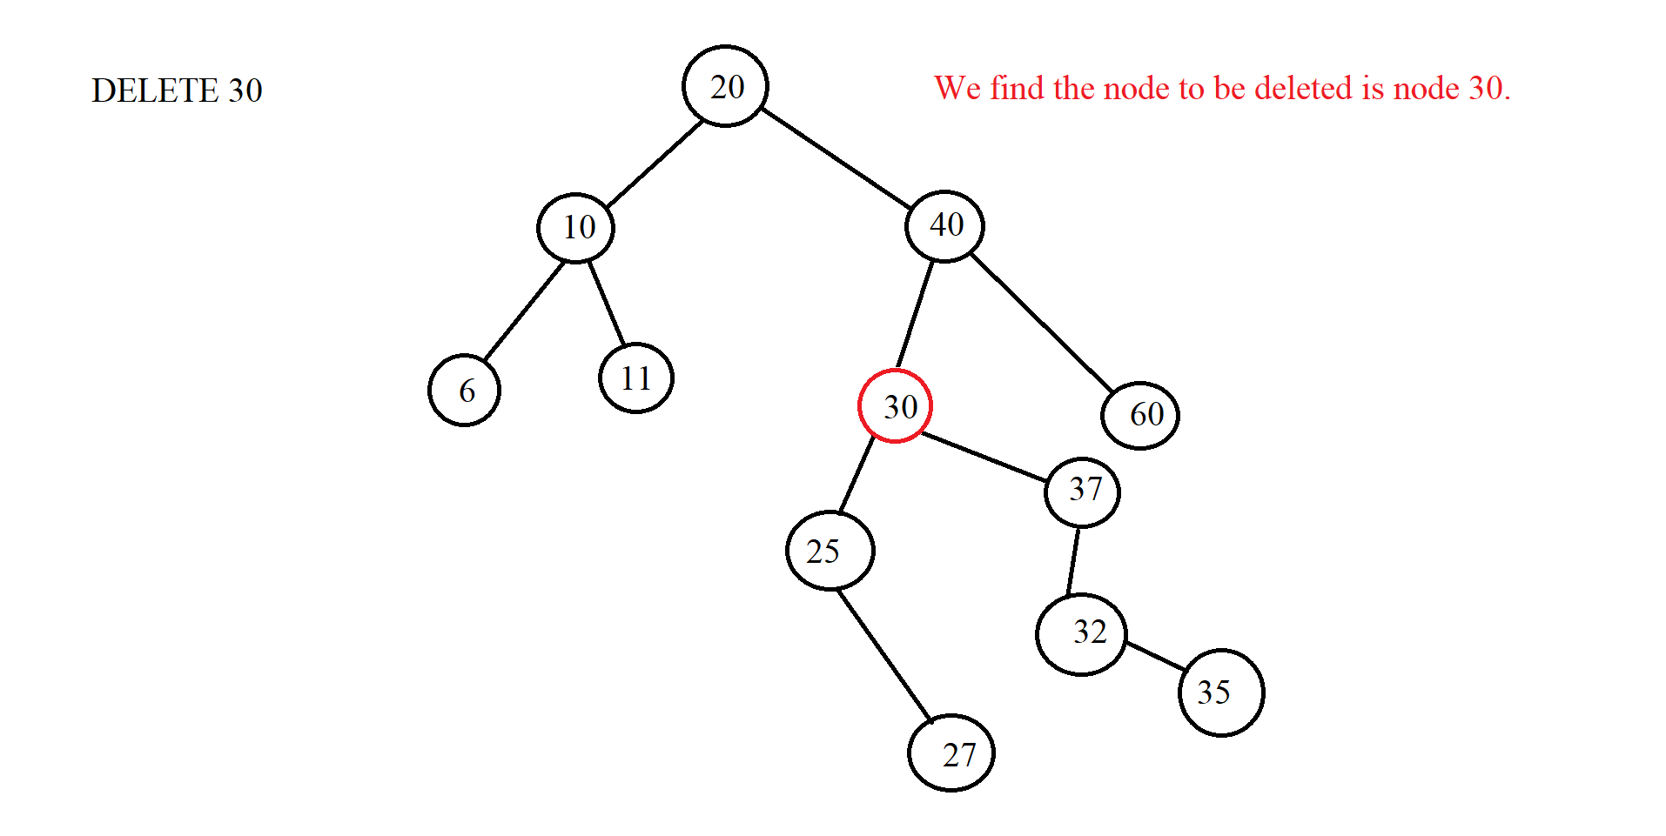

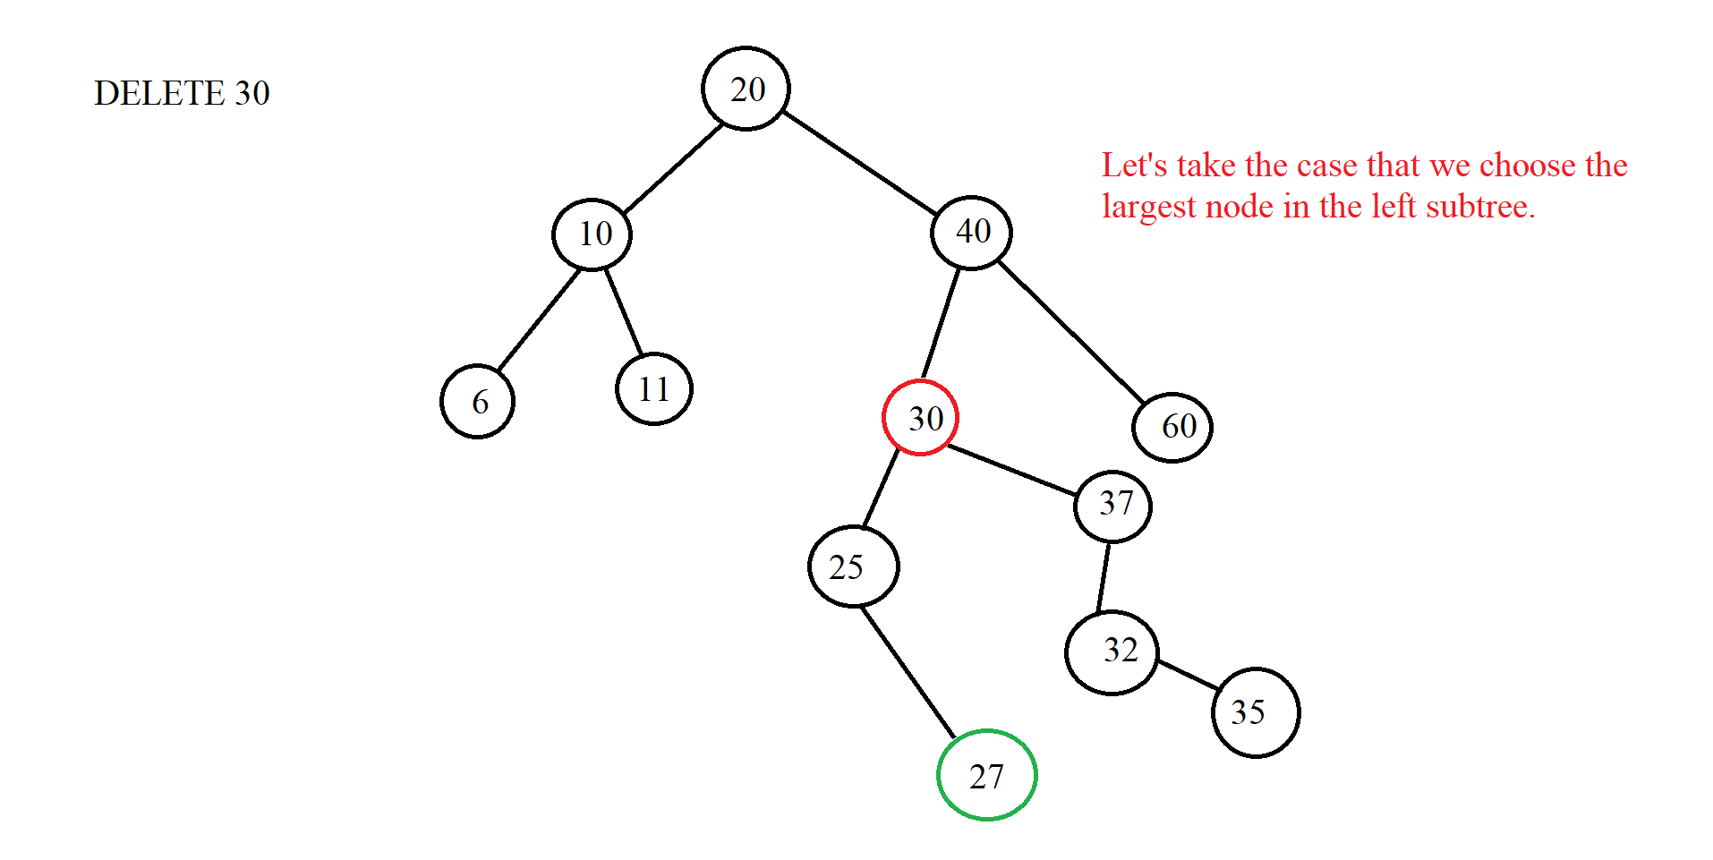

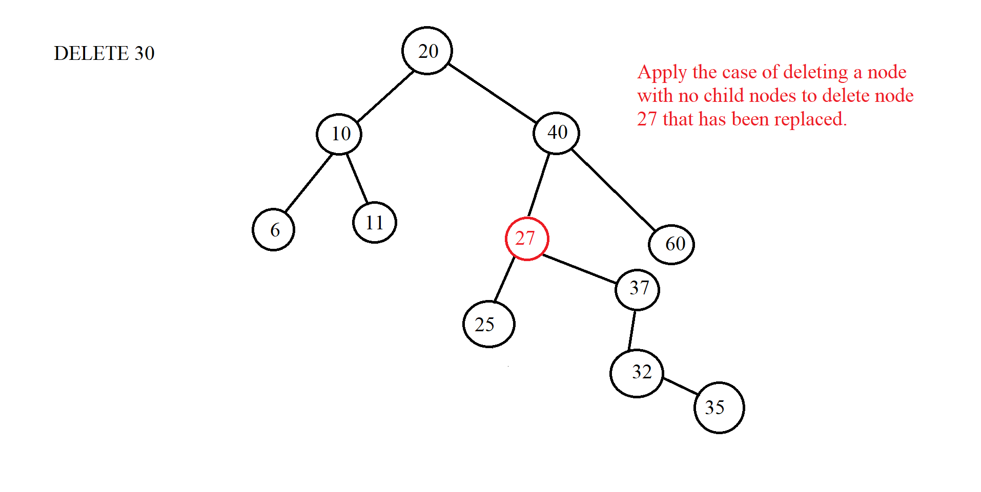

(Let's say we want to get the smallest node of the right subtree instead)



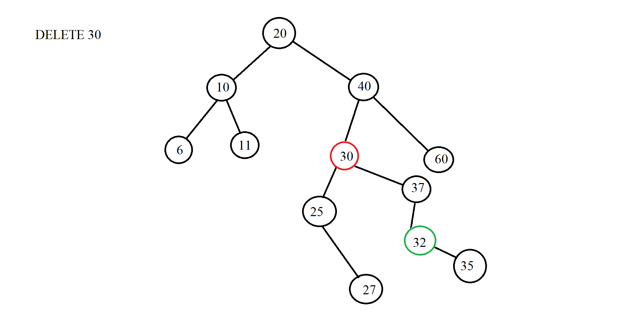

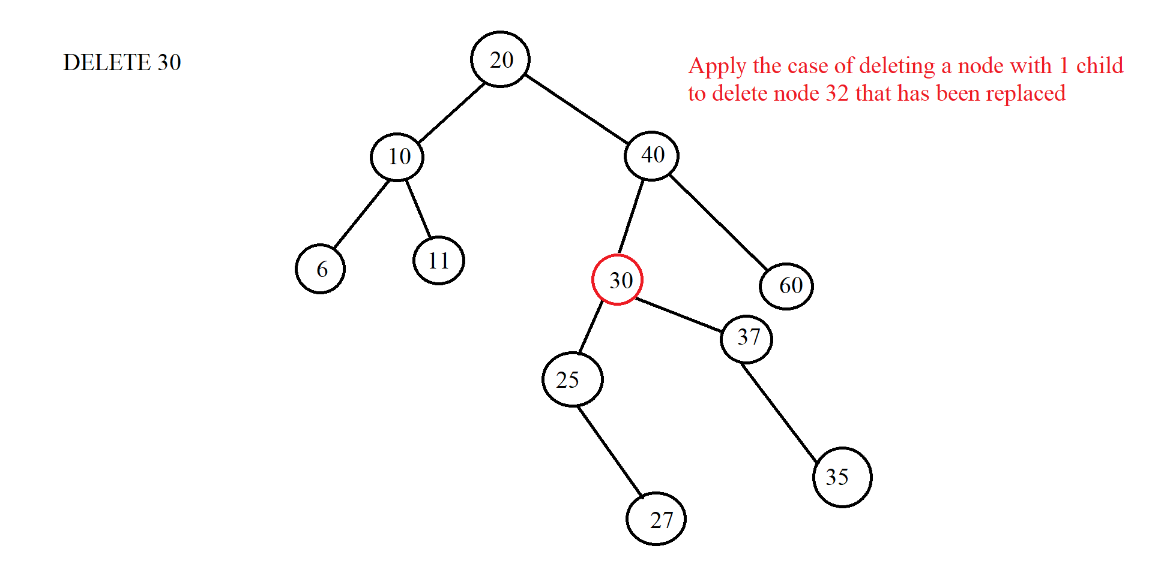



|  |
| --- |
|  |

### III. Illustration examples

*Example 1:*

* **INPUT:**

-Insert:32, 20, 10, 15, 40, 25, 27, 26, 5, 13, 14.

-Find: 15, 29

-Delete: 25, 40 , 20

* **OUTPUT:**

-Insert:

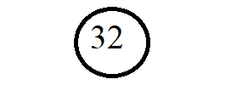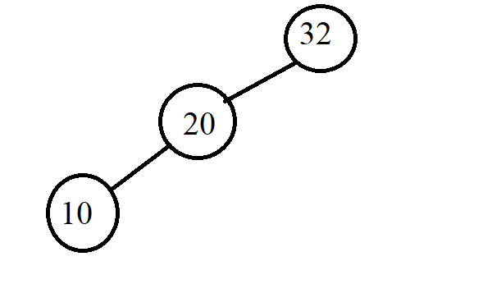

a

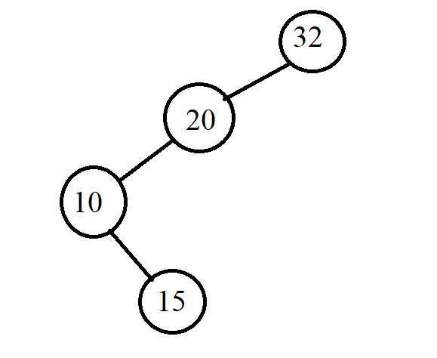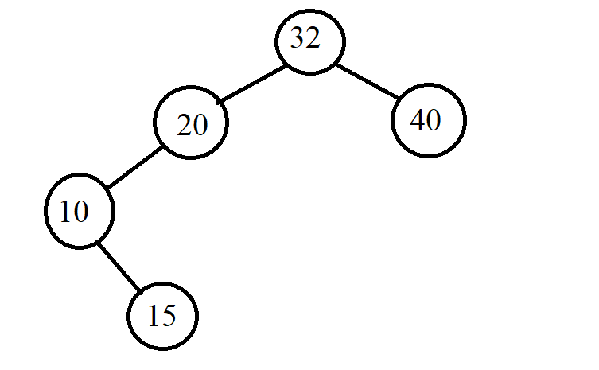 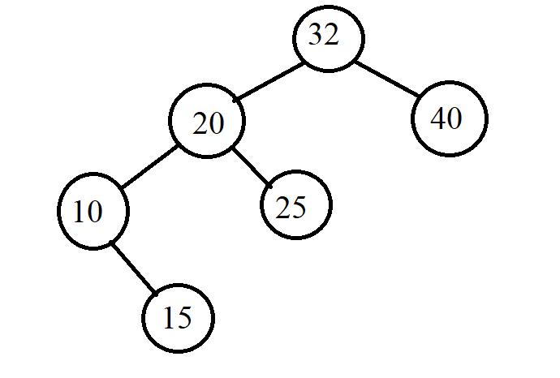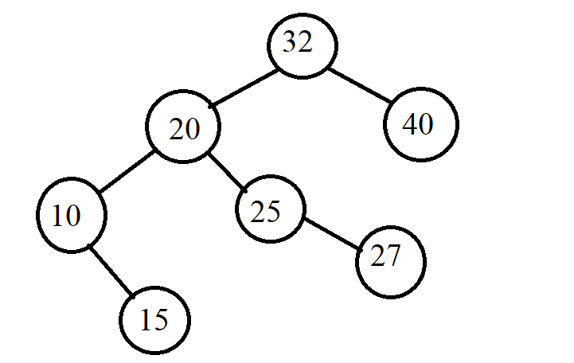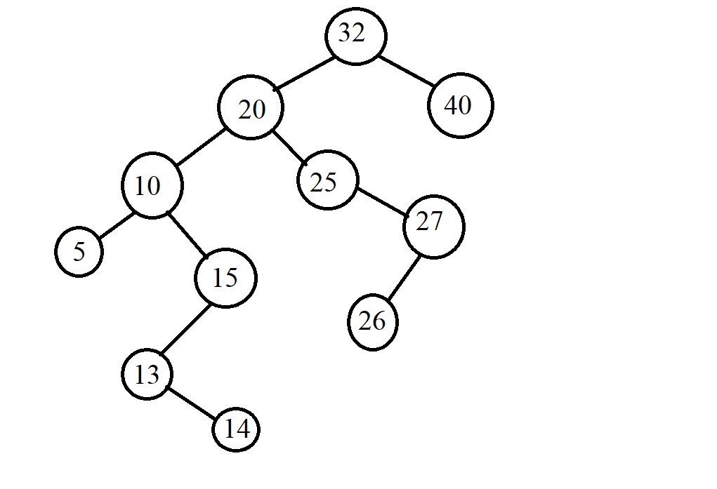

-Find:

Find 15:

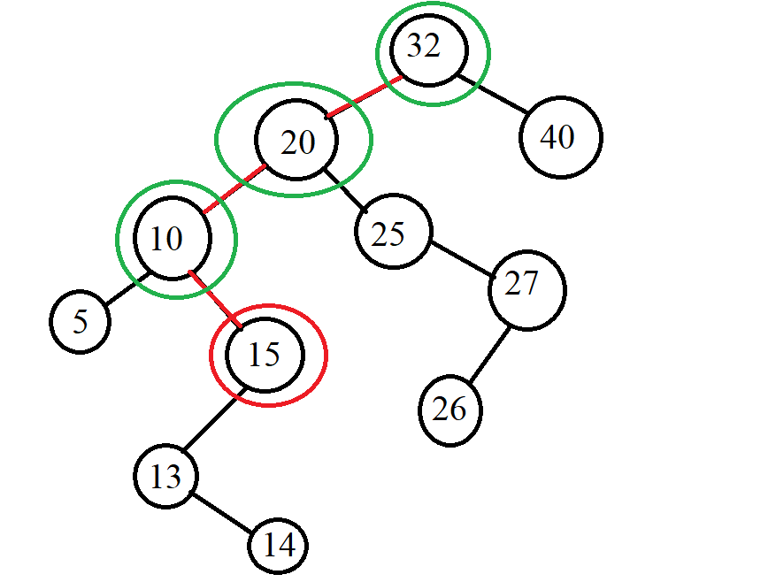

Find 29:

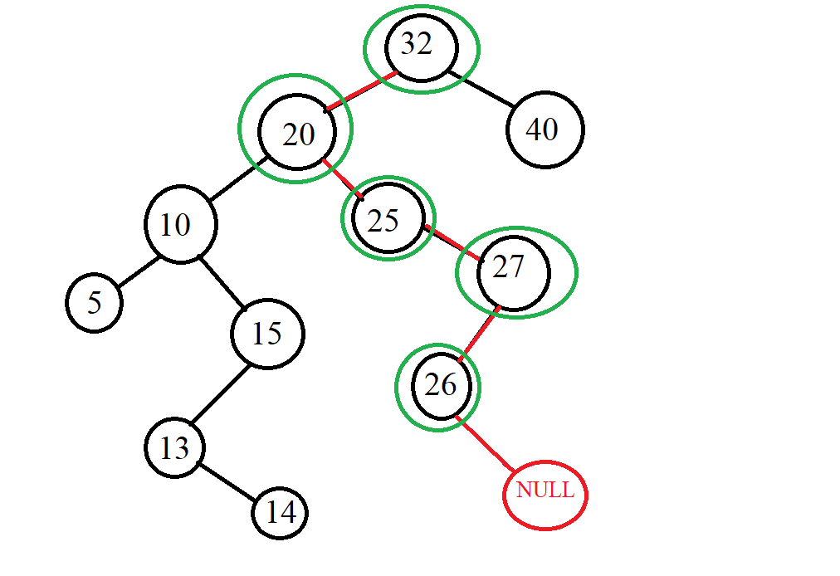

-Delete:

Delete 25

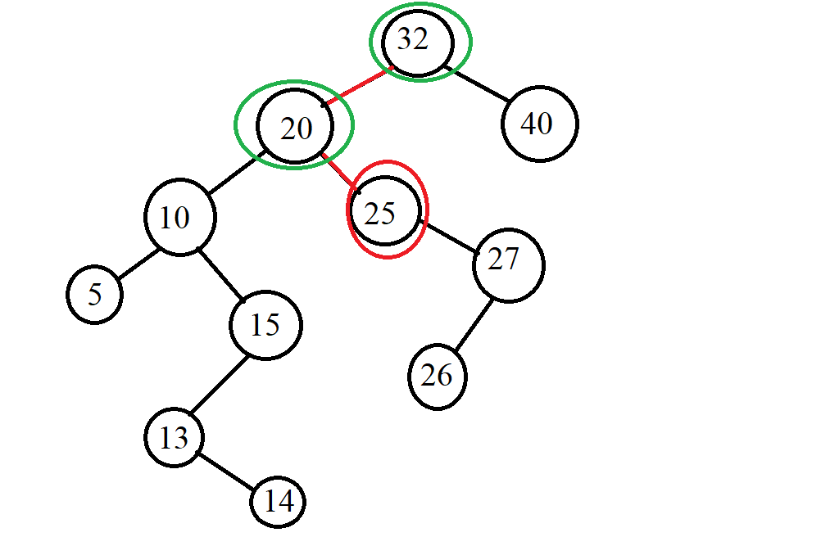 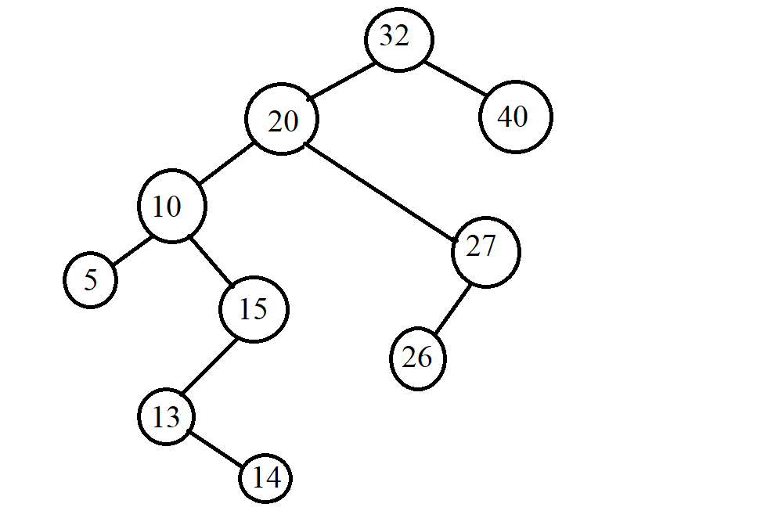

Delete 40:

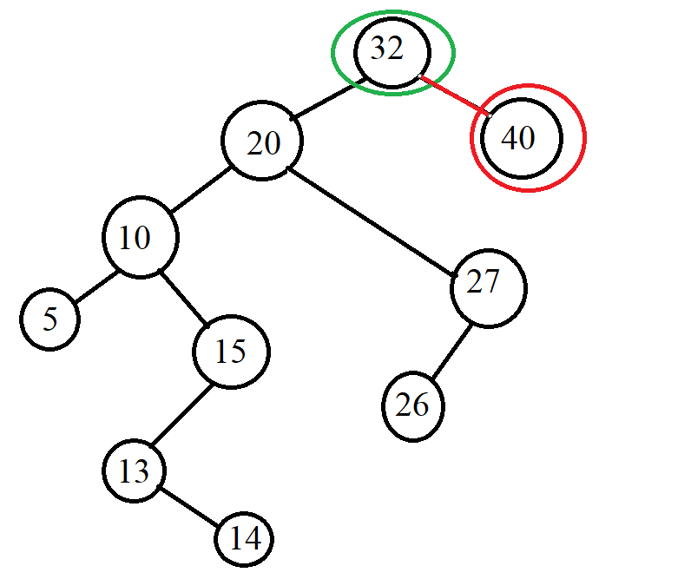

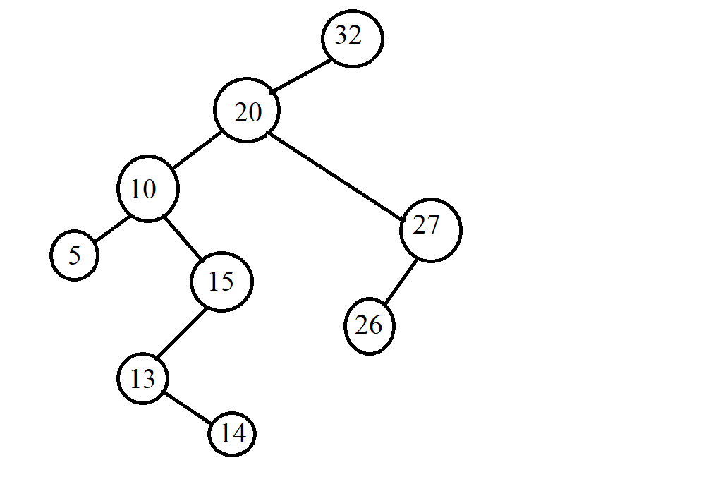

Delete 20:

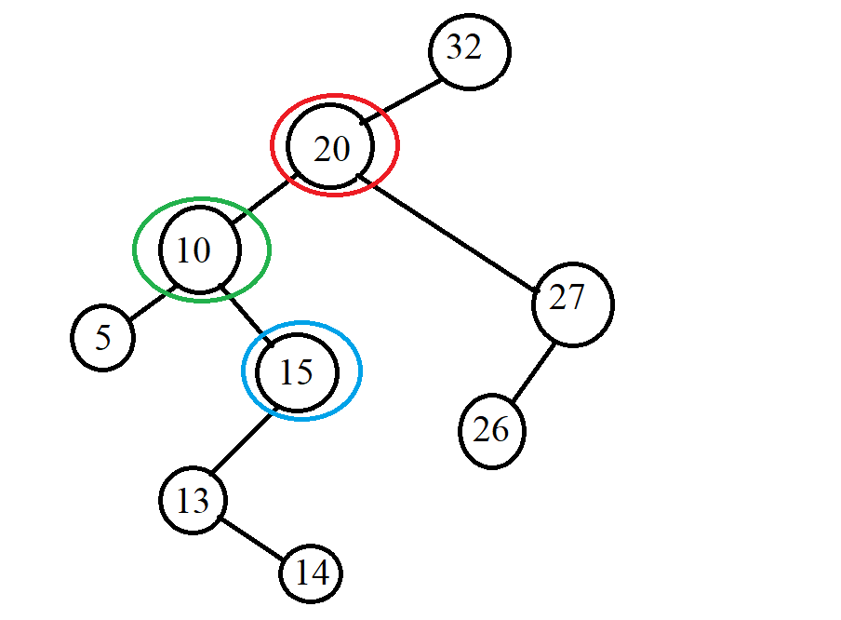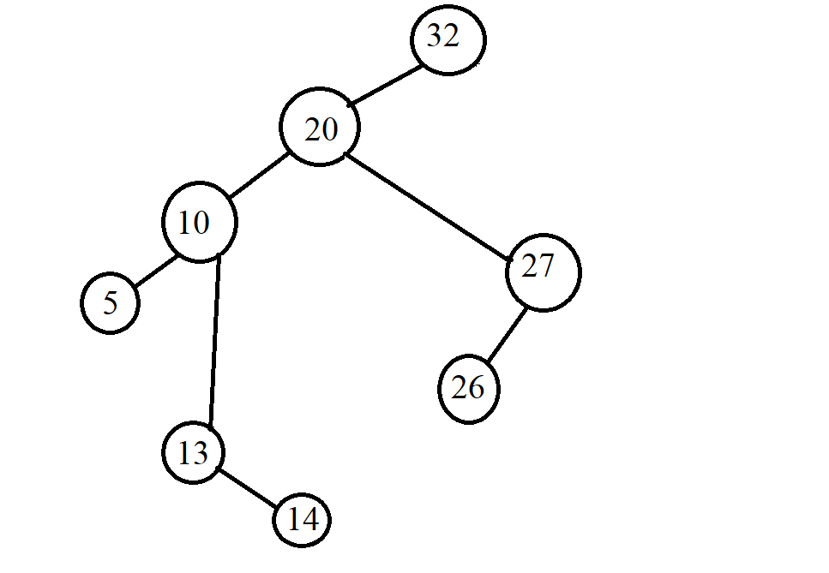

*Example 2:*

* **INPUT:**

-Insert: G, J, A, T, B, W, C, K.

-Find: A, Z

-Delete: J, A

* **OUTPUT:**

-Insert:

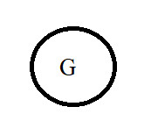 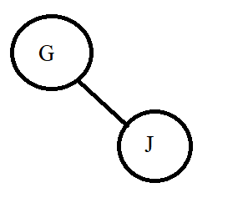

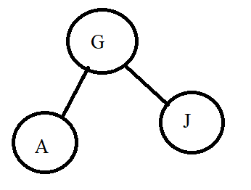 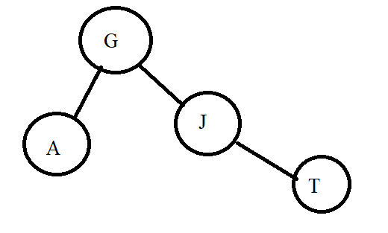

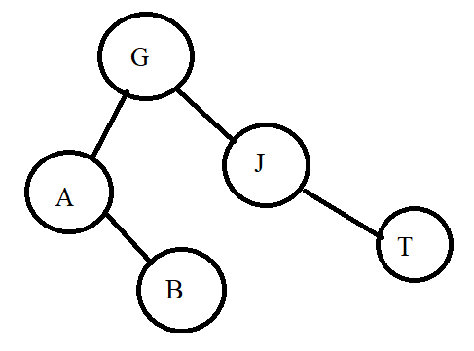 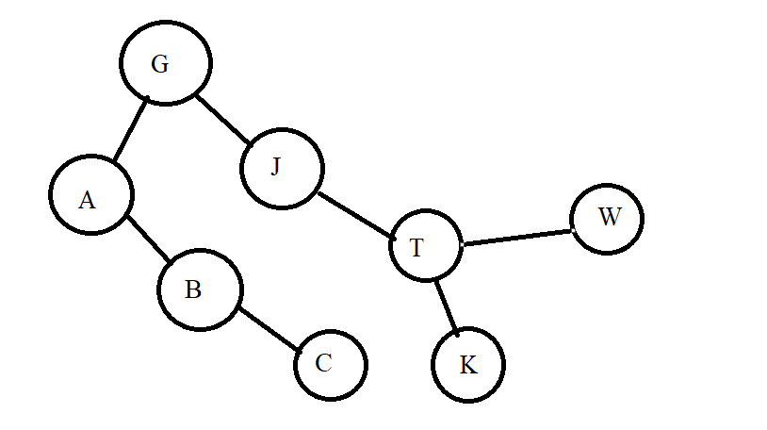

-Find:

Find A

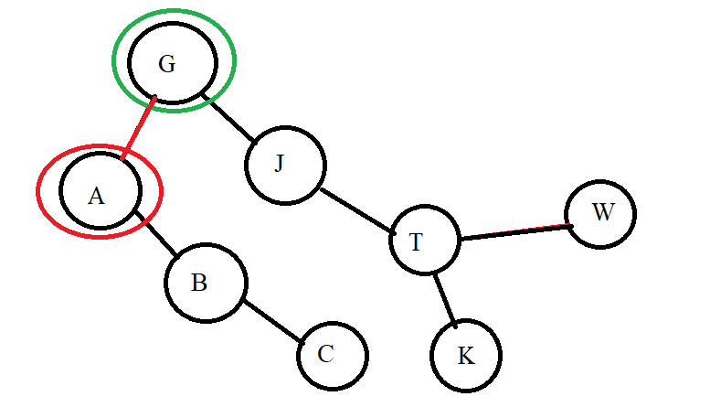

.Find Z

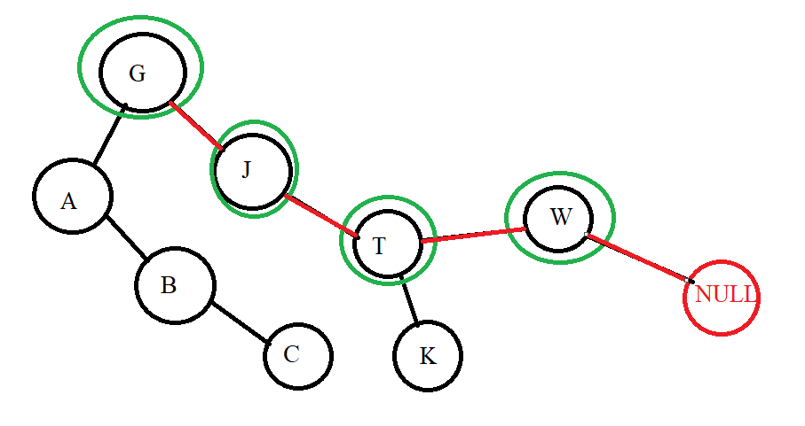

-Delete:

Delete J:

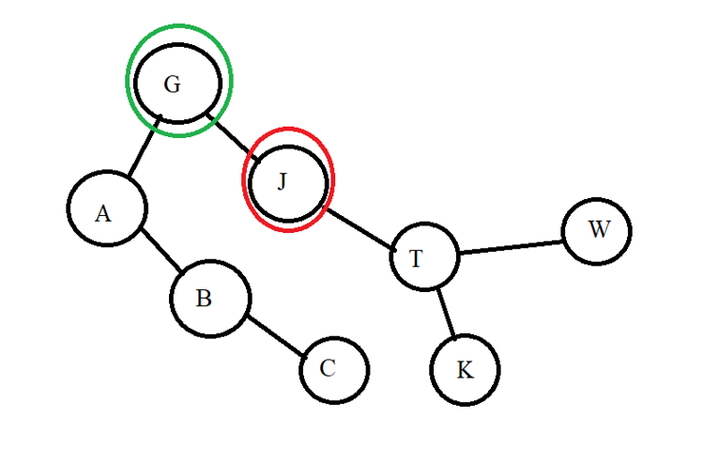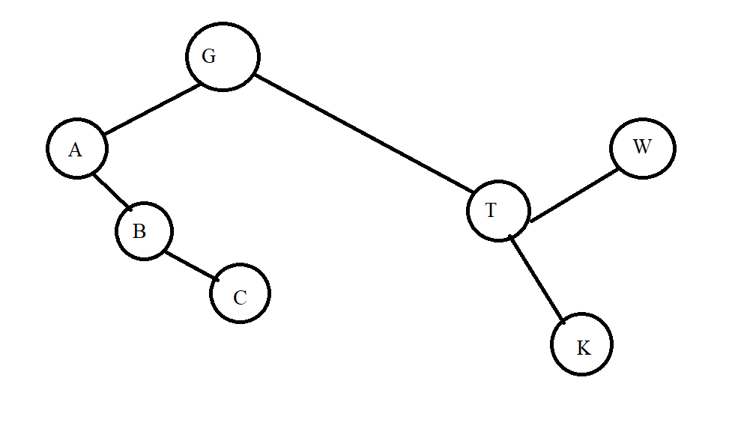

Delete A:

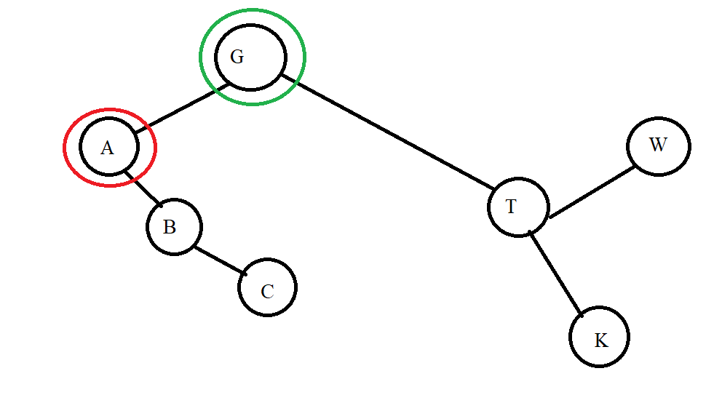

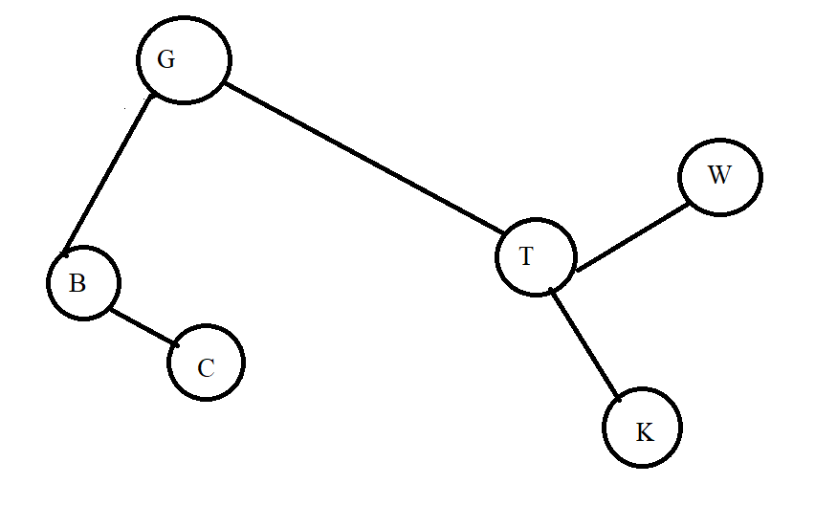

*Example 3:*

* **INPUT:** input is a data pair of the form (x,y) where x is an integer and y is a letter. We will compare the number first if the number is equal, we compare the letter.

**-**Insert: (5,g), (4,b), (5,a), (9,e), (2,p), (1,z)

**-**Find: (9,e), (7,a)

**-**Delete: (5,g), (2,p)

* **OUTPUT:**

-Insert:

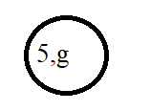 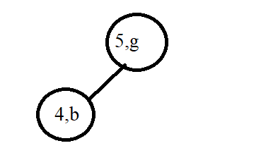

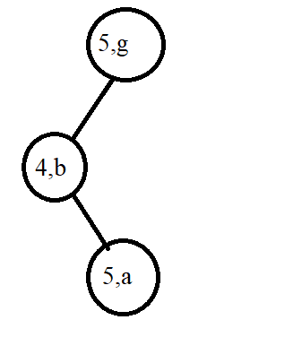 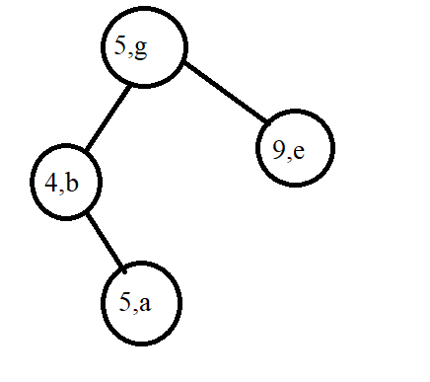

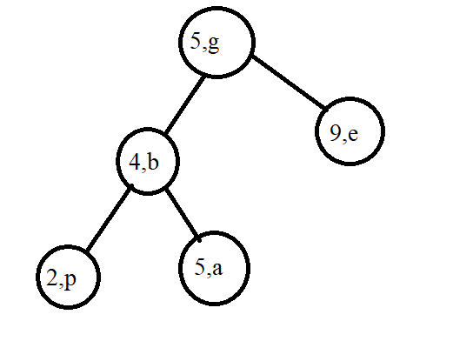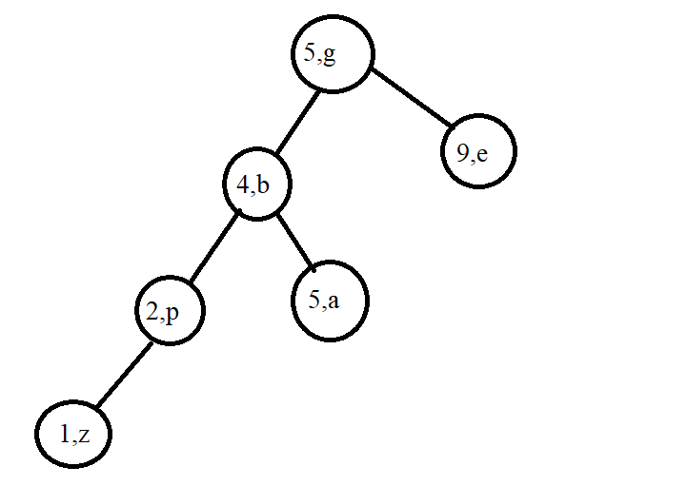

-Find:

.Find (9,e)

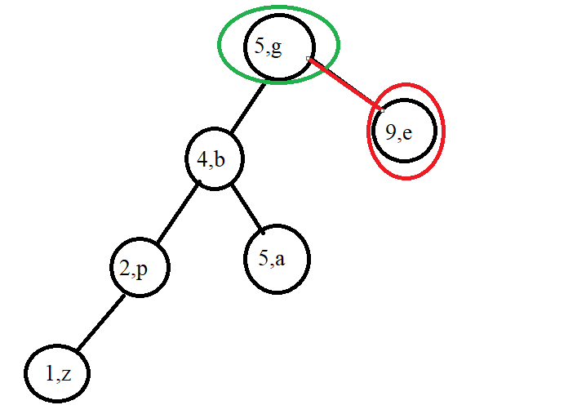

.Find (7,a)

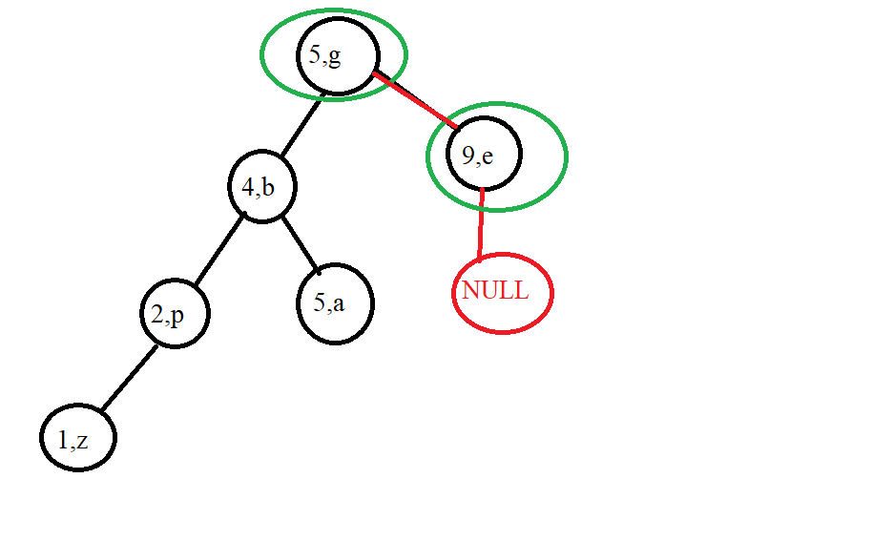

Delete:

.Delete (5,g)

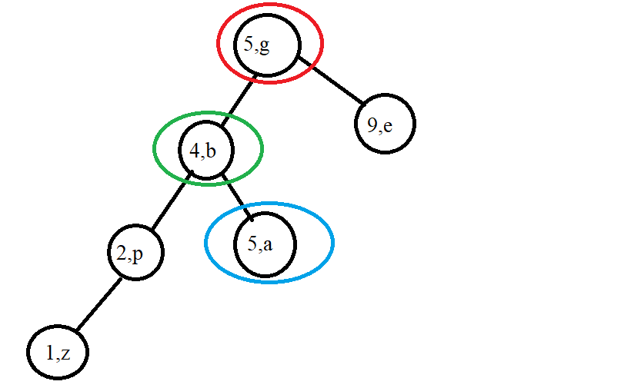

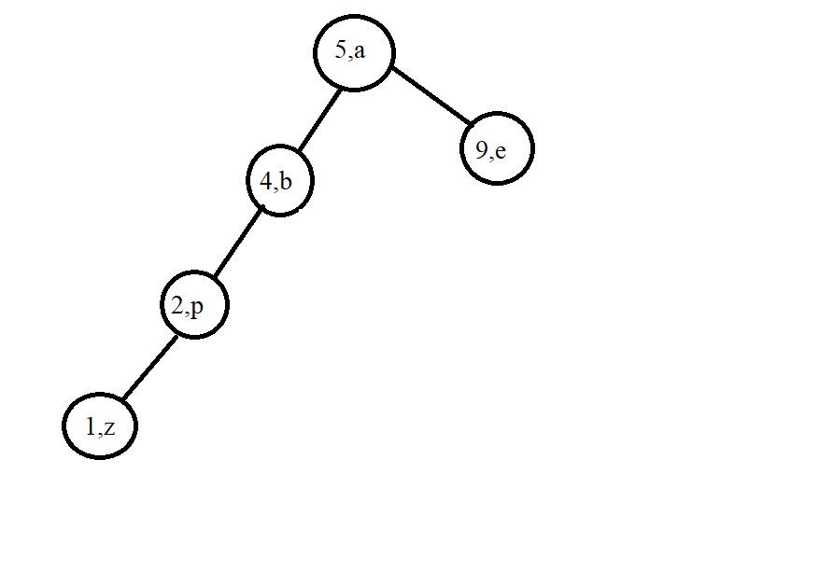

.Delete (2,p)

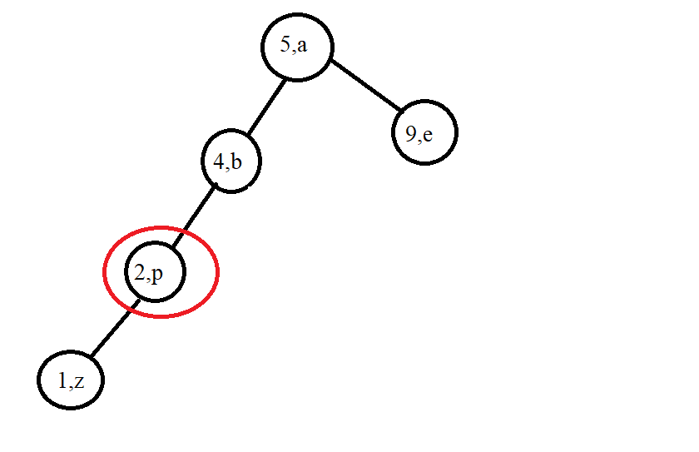

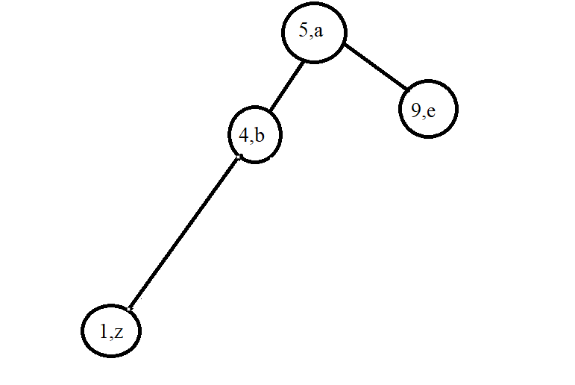

## Lession 4: Balanced tree (AVL)

**Contents:**

* **Introduction**
* **Operations on AVL Tree**
* **Illustration examples**

### I. Introduction

**\***Question:

-If we keep inserting elements into the BST tree in ascending order of 1,2,3, 4… or descending, for example, 1000, 999,....then when we insert millions of numbers or the whole input ratio in that order, we will create a tree that leans left or right. Example:

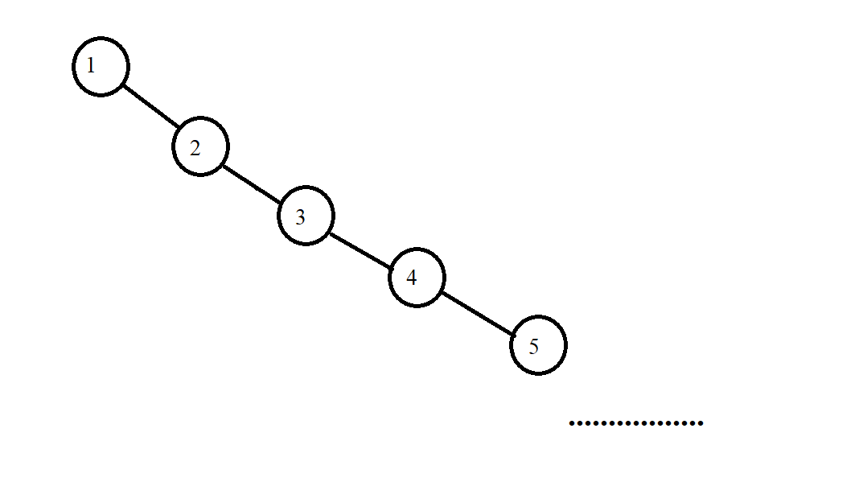

*The main content of the balanced tree:

-The AVL is:

+A search binary tree: That is, it also has only 2 children in each node, where the left child node is smaller than the parent node and the right child node is larger than the parent node.

+The key to a balanced tree is: At each node, the difference between left and right subtrees is less than or equal to 1. Note here that the concept of equilibrium is not that the left and right subtrees are equal, but that their difference is less than or equal to 1 because in the case of two equal left and right subtrees, it is too good to achieve. I have the formula:

∀p ∈ TAVL :(hp −> Left − hp −> Right) ≤ 1

Example:

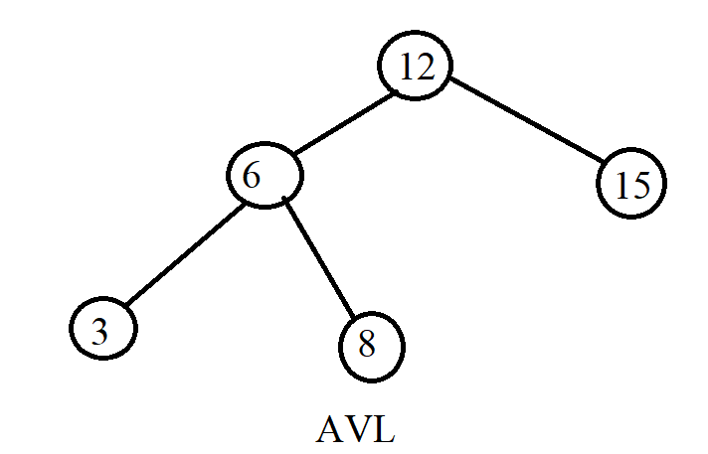

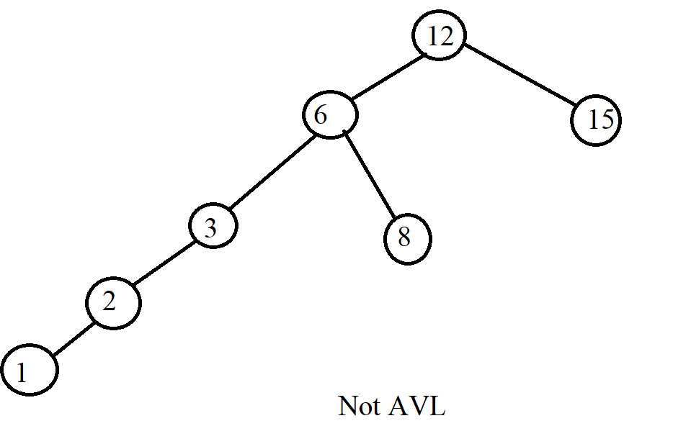

### II. Operations on AVL Tree

How to declare in a node:



-Balance: We call getBalance a function that tells us whether it is unbalanced or unbalanced. If it is out of balance, it will tell us which side it is unbalanced.

+If getBalance = 1: Right child node is more than left child node.

+If getBalance = -1: Left child node is more than right child node

+ The rest is in the case of a balanced tree.





Example:

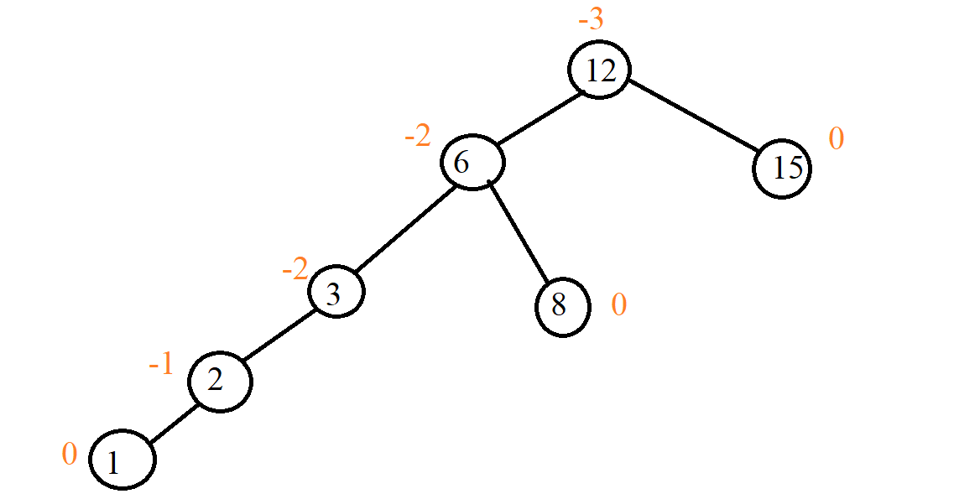

- Adjust the tree to balance: There are two operations on the tree that make the tree unbalanced: insertion and deletion because then we have changed the state of the tree. In the case of inserting an element into the tree, we have the ability to make the parent node of the node we just inserted unbalanced or the nodes on it also fall into the unbalanced case and in the case of deletion, it will too.

Example:

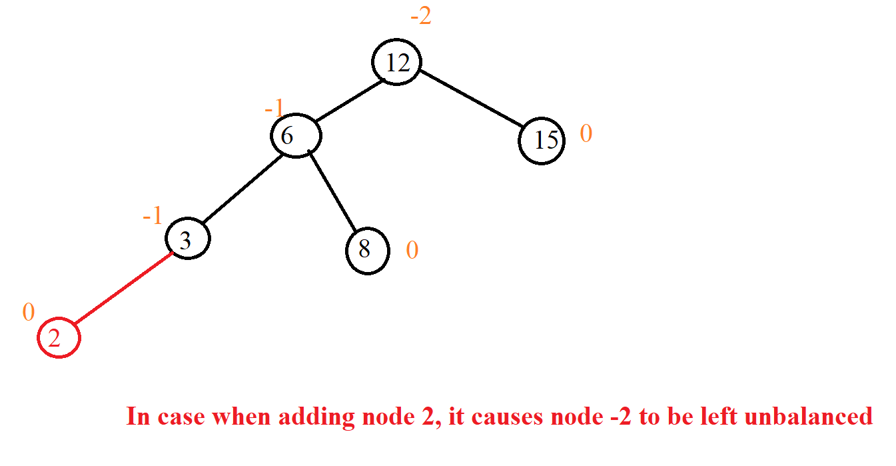

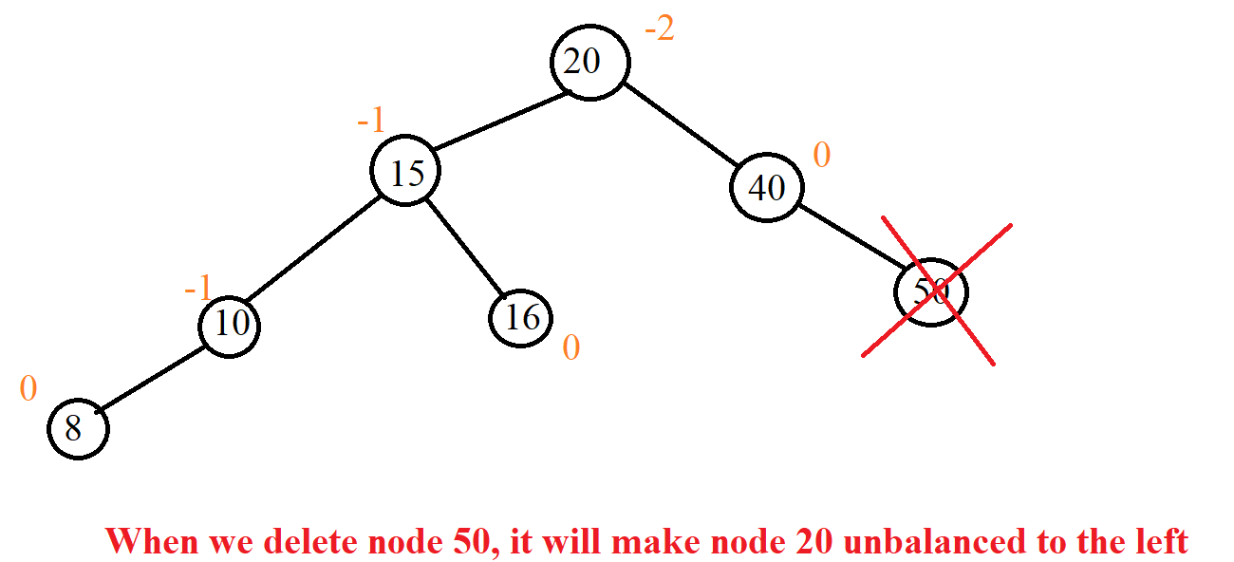

So, the question is, what should we do when we fall into that situation? The answer is that we use tree correction.

- Before going into editing the tree, we must see how to rotate 2 nodes because when editing the tree, we rotate the node for it to become an AVL tree.

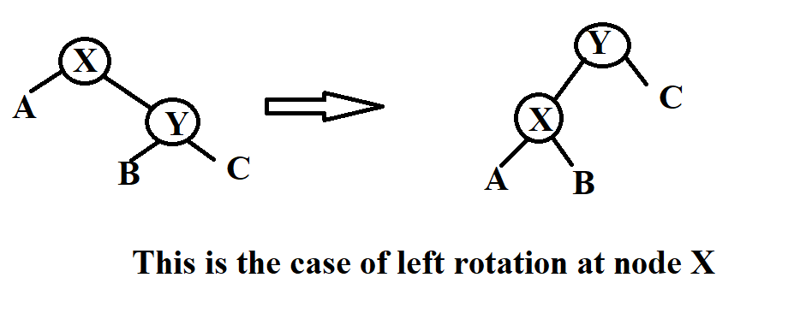

Node* leftRotate(Node* x)

{ Node* y = x->right;

Node* T2 = y->left;

// Perform rotation

y->left = x;

x->right = T2;

// Update heights

x->height = max(height(x->left),

height(x->right)) + 1;

y->height = max(height(y->left),

height(y->right)) + 1;

// Return new root

return y; }

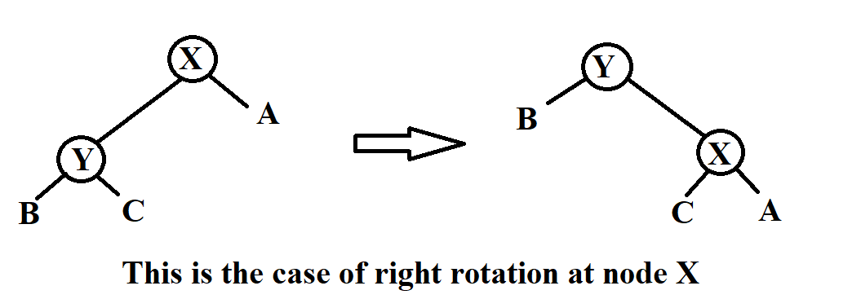

Node* rightRotate(Node* y)

{

Node* x = y->left;

Node* T2 = x->right;

// Perform rotation

x->right = y;

y->left = T2;

// Update heights

y->height = max(height(y->left),

height(y->right)) + 1;

x->height = max(height(x->left),

height(x->right)) + 1;

// Return new root

return x;

}

- We have 4 cases to edit the tree which are Left-Left Case, Right-Right Case, Left-Right Case and Right-Left Case. But we only need to know 2 cases, Left Left Case and Left Right Case because the other 2 cases we do the same but on different sides.

+Left-Left Case (L-L): In this case we remember that the node is left unbalanced, the left child of that node is also unbalanced to the left.

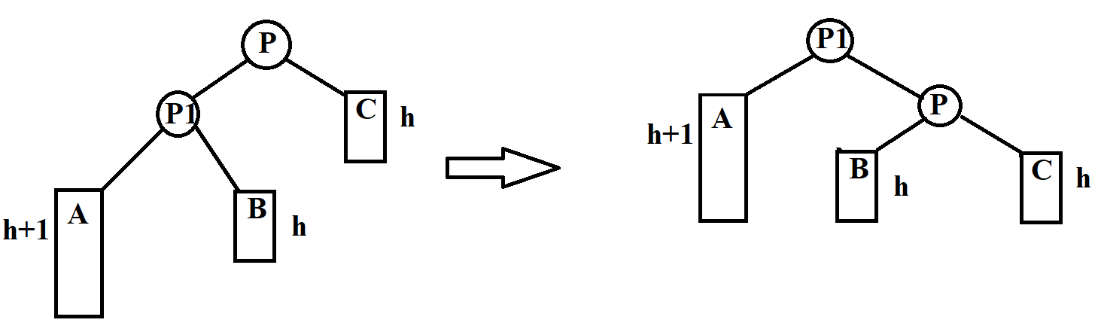

Example:

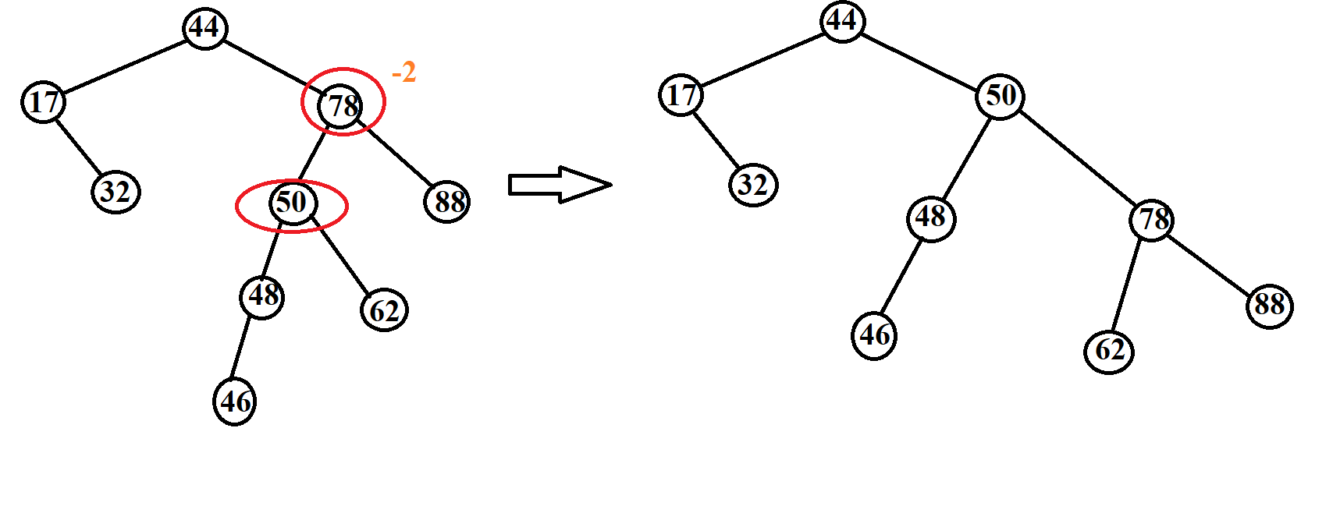

+Left_Right Case (L-R): In this case we remember that the left node is unbalanced, the left child of that node is also unbalanced on the right.

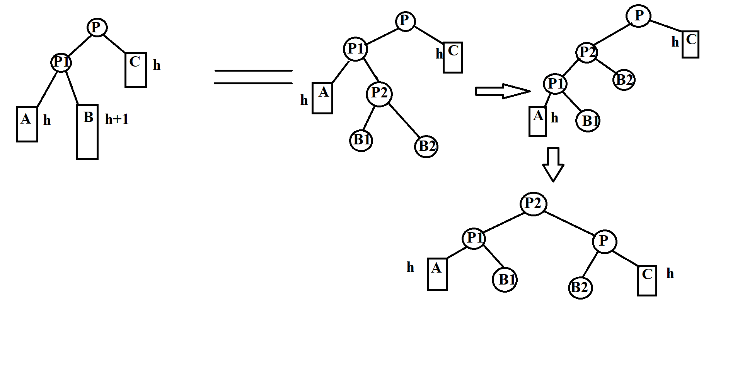

Example:

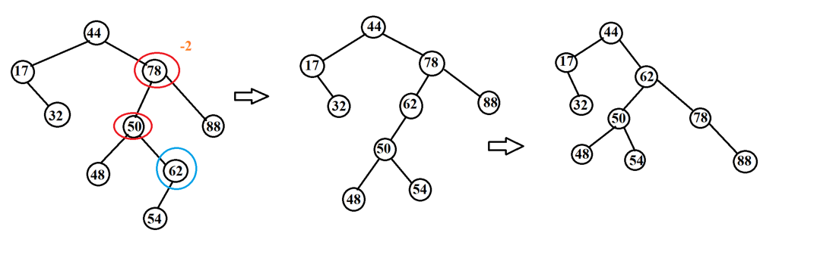

-Insert, delete: How tree-like insert and delete BST but the other is in step when done, we must calibrate the balance tree (we only balance when the length of the left subtree minus the length of the right subtree and we take abs, the result is large more than 1).

+Insert: When it is finished, we will go back to the previously reviewed nodes to see if that node is unbalanced or not.

Node* insert(Node*node, int key)

{

/* 1. Perform the normal BST rotation */

if (node == NULL)

{

//node = newNode(key);

return(newNode(key));

}

if (key < node->key)

node->left = insert(node->left, key);

else if (key > node->key)

node->right = insert(node->right, key);

else // Equal keys not allowed

return node;

/* 2. Update height of this ancestor node */

node->height = 1 + max(height(node->left), height(node->right));

/* 3. Get the balance factor of this

ancestor node to check whether

this node became unbalanced */

int balance = getBalance(node);

// If this node becomes unbalanced,

// then there are 4 cases

// Left Left Case

if (balance > 1 && key < node->left->key)

return rightRotate(node);

// Right Right Case

if (balance < -1 && key > node->right->key)

return leftRotate(node);

// Left Right Case

if (balance > 1 && key > node->left->key)

{

node->left = leftRotate(node->left);

return rightRotate(node);

}

// Right Left Case

if (balance < -1 && key < node->right->key)

{

node->right = rightRotate(node->right);

return leftRotate(node);

}

/* return the (unchanged) node pointer */

return node;

}

Example: when we add 60

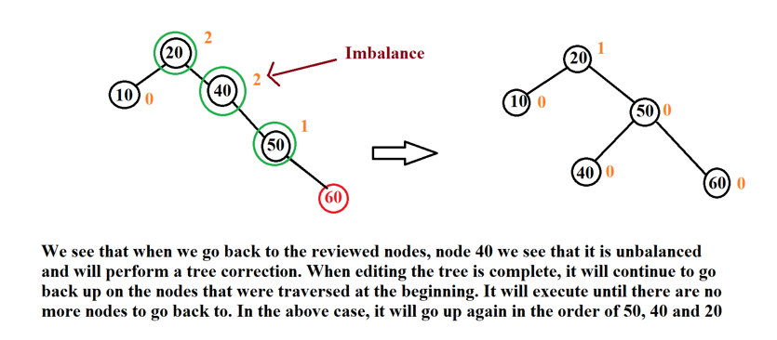

+Delete: When it is finished, we will go back to the previously reviewed nodes to see if that node is unbalanced or not.

Node* deleteNode(Node* root, int key)

{

if (root == NULL)

return root;

if (key < root->key)

root->left = deleteNode(root->left, key);

else if (key > root->key)

root->right = deleteNode(root->right, key);

else

{

// node with only one child or no child

if ((root->left == NULL) ||

(root->right == NULL))

{

Node* temp = root->left ? root->left : root->right;

// No child case

if (temp == NULL)

{

temp = root;

root = NULL;

}

else // One child case

*root = *temp; // Copy the contents of

// the non-empty child

free(temp);

}

else

{

Node* temp = minValueNode(root->right);

root->key = temp->key;

// Delete the inorder successor

root->right = deleteNode(root->right,

temp->key);

}

}

if (root == NULL)

return root;

root->height = 1 + max(height(root->left),

height(root->right));

int balance = getBalance(root);

// Left Left Case

if (balance > 1 &&

getBalance(root->left) >= 0)

return rightRotate(root);

// Left Right Case

if (balance > 1 &&

getBalance(root->left) < 0)

{

root->left = leftRotate(root->left);

return rightRotate(root);

}

// Right Right Case

if (balance < -1 &&

getBalance(root->right) <= 0)

return leftRotate(root);

// Right Left Case

if (balance < -1 &&

getBalance(root->right) > 0)

{

root->right = rightRotate(root->right);

return leftRotate(root);

}

return root;

}

-Complexity and tree height:

+Tree height:

. hAVL <1.44log2(N + 1).

. AVL tree is 44% higher than optimal BST tree.

+ Complexity:

. Search: O($\log_{2}{N}$).

. Adding an element: O($\log_{2}{N}$), including tree search O($\log_{2}{N}$) and editing O($\log_{2}{N}$).

. Deleting element O(log2N), including tree search O($\log_{2}{N}$) and editing O($\log_{2}{N}$).

### III. Illustration examples

*Example 1:*

**INPUT:**

-Insert:32, 20, 10, 15, 40, 25, 27, 26, 13, 14.

-Find: 15, 29

-Delete: 25, 40, 20

**OUTPUT:**

-Insert:

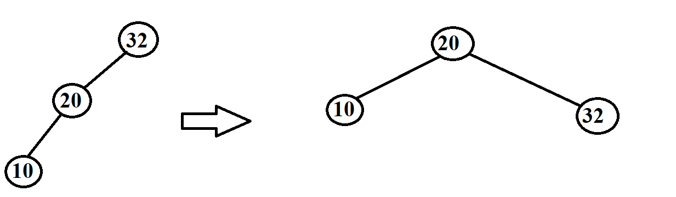

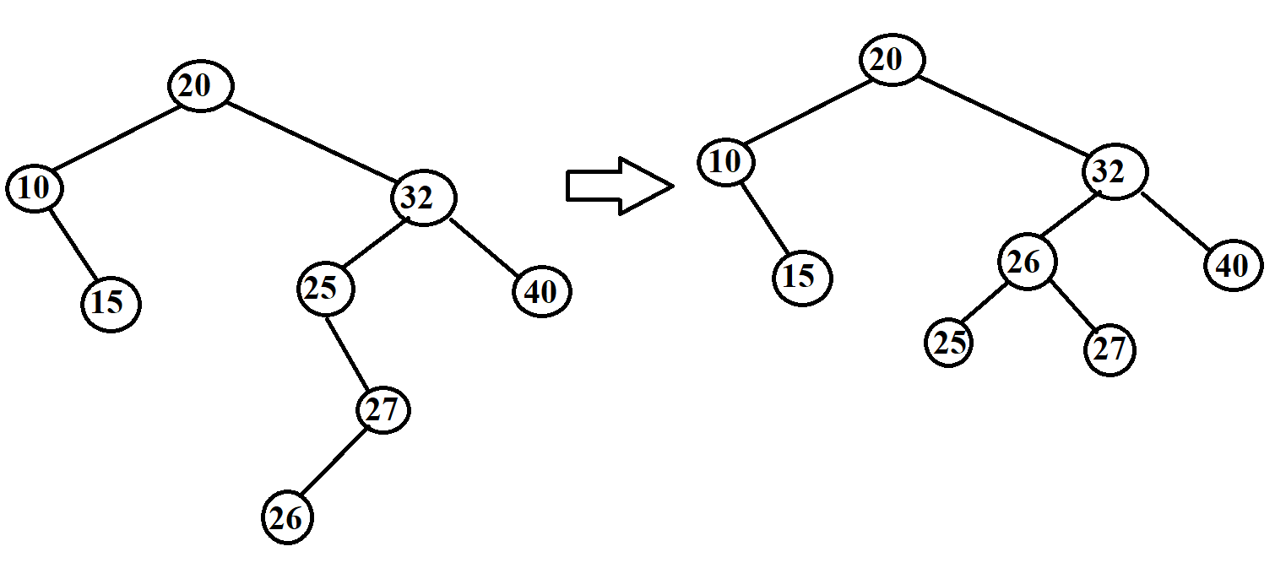

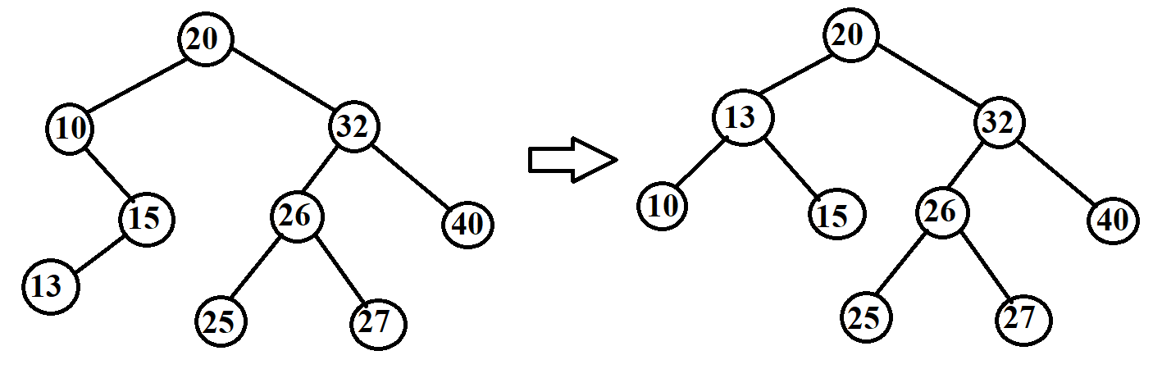

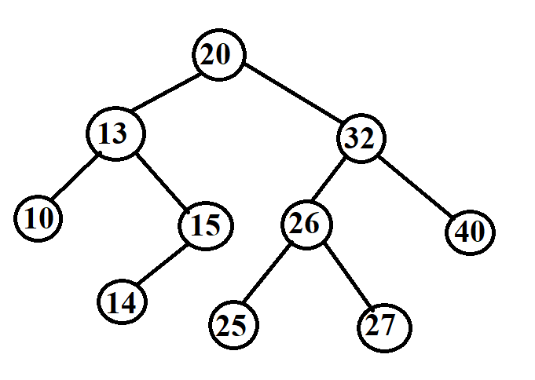

-Find:

+Find 15

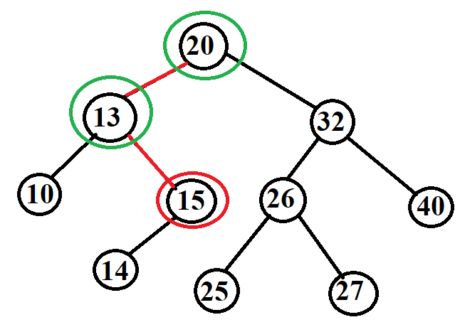

+Find 29

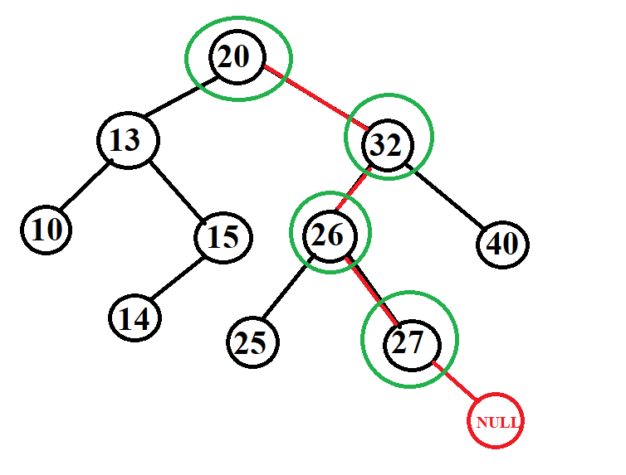

-Delete:

+Delete 25

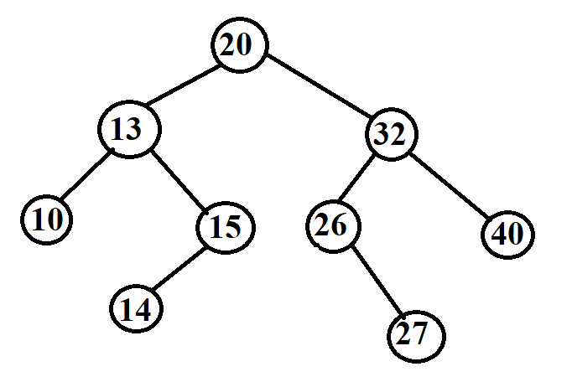

+Delete 40

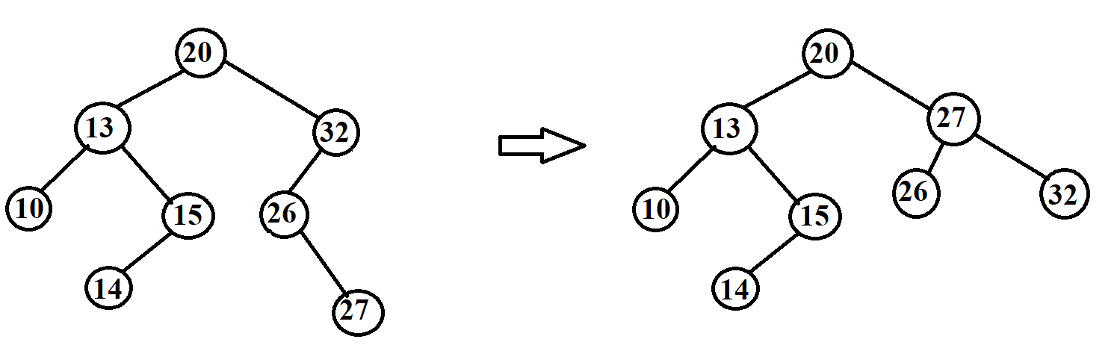

+Delete 20

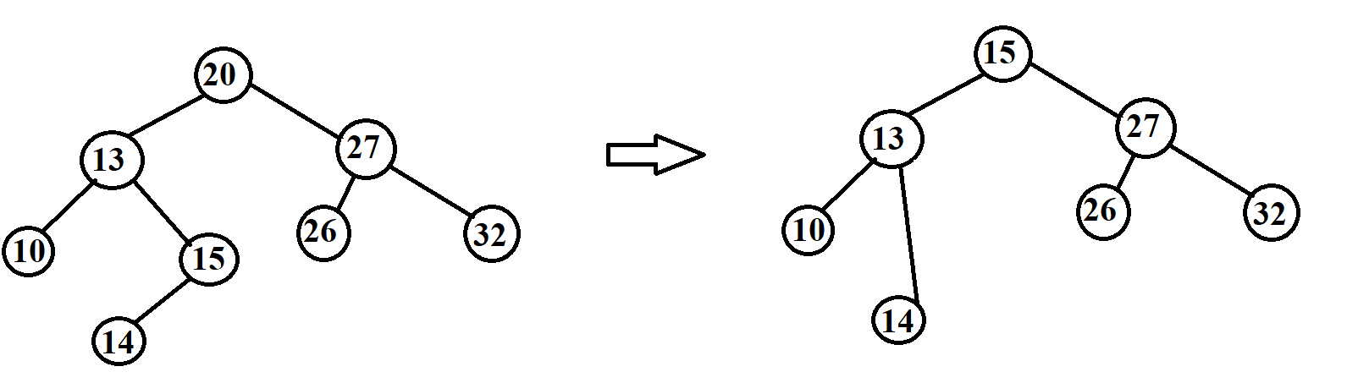

*Example 2:*

**INPUT:**

-Insert: G, J, A, T, B, W, C, K.

-Find: A, Z

-Delete: J, A

**OUTPUT:**

-Insert:

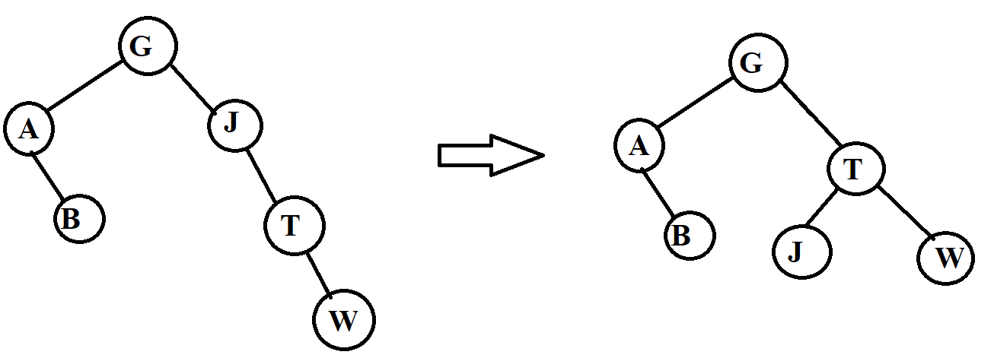

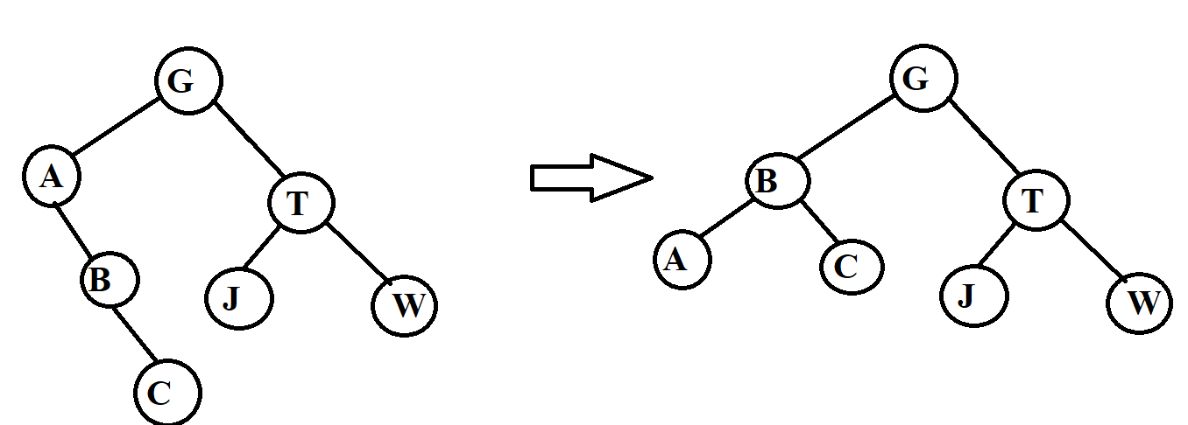

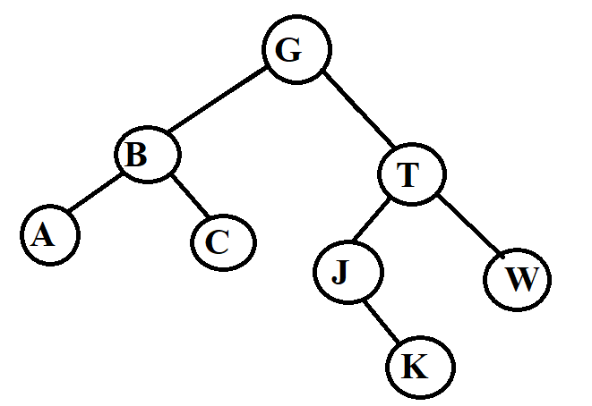

-Find:

+Find A.

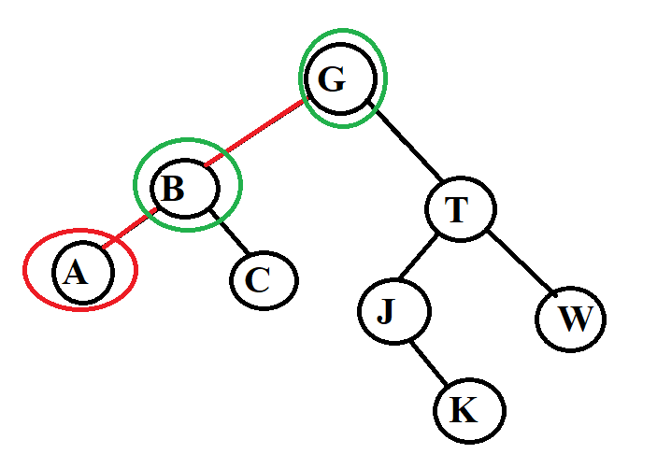

+Find Z.

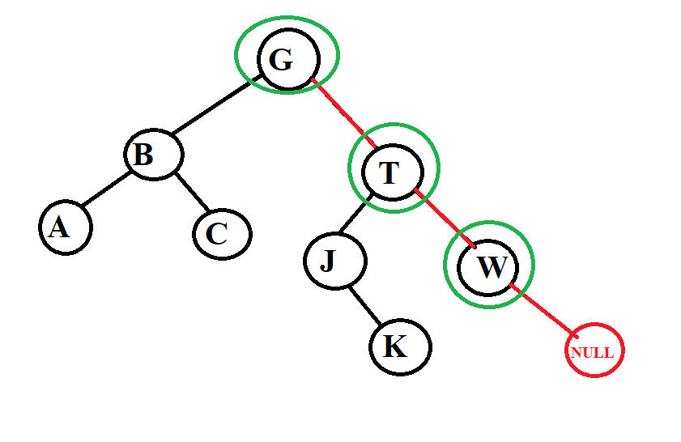

-Delete:

+Delete J

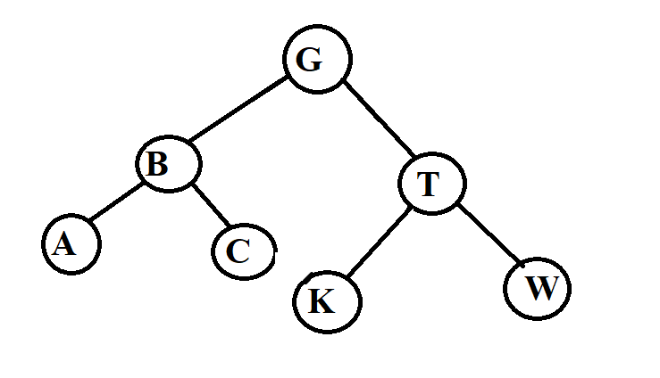

+Delete A

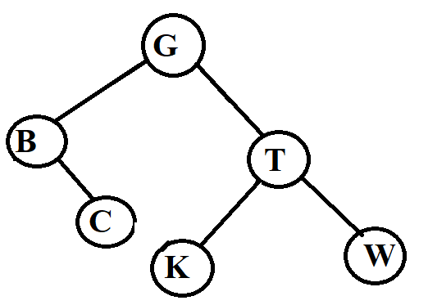

*Example 3:*

**INPUT:** input is a data pair of the form (x,y) where x is an integer and y is a letter. We will compare the number first if the number is equal, we compare the letter.

**-**Insert: (5,g), (4,b), (5,a), (9,e), (2,p), (1,z)

**-**Find: (9,e), (7,a)

**-**Delete: (5,g), (2,p)

**OUTPUT:**

-Insert:

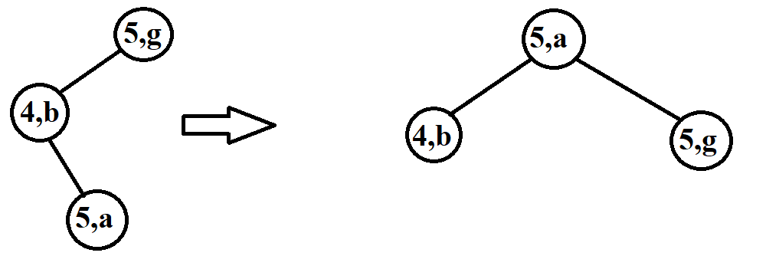

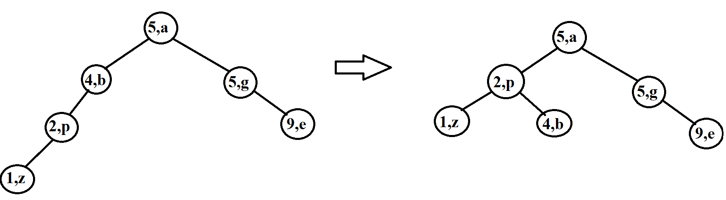

**-**Find:

**+**Find (9,e)

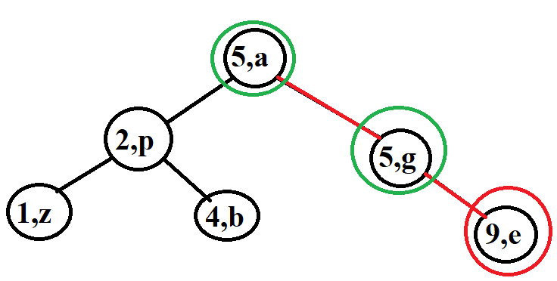

**+**Find (7,a)

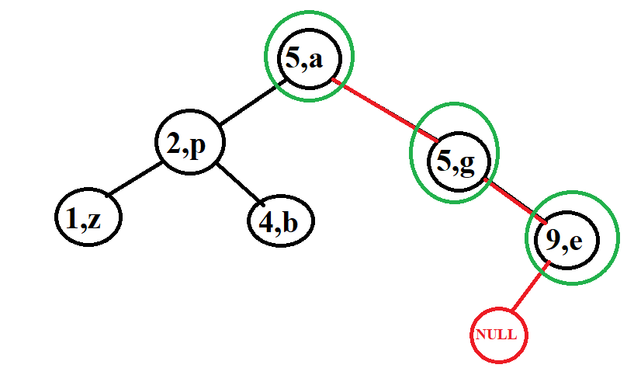

-Delete:

+Delete (5,g)

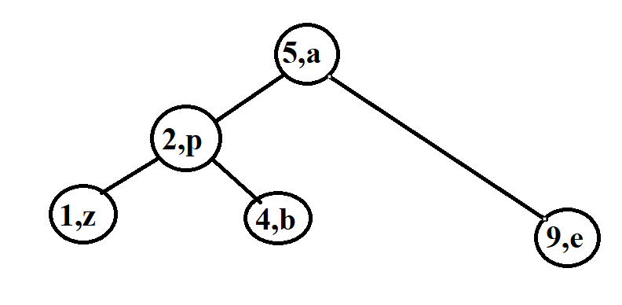

+Delete (2,p)

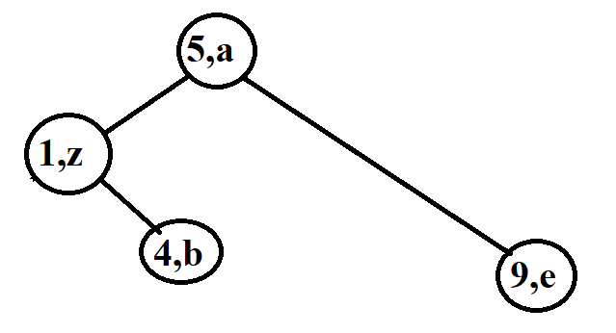

## Lession 5: Red-Black Tree (RB Tree)

**Contents:**

* **Introduction**
* **Operations on AVL Tree**
* **Illustration examples**
* **Compare AVL and RB tree**

### I. Introduction

**\***Question:

-Is there a balanced search tree that has fewer structural changes in the tree but is faster to find, delete and insert than an AVL tree in practice? The answer is yes, it is a red black tree as fewer rotations are done due to relatively relaxed balancing.

*The main content of the Red-Back tree:

-Red-Black Tree is a binary search tree.

-It must satisfy 5 principles:

[1] Each node is red or black.

[2] The root node is always black.

[3] Node NULL is always black. In a B Tree, we will call the NULL node NIL because it has the unique properties of the RB Tree such as color.

[4] If that node is red then its child node is black. That means there is no case of 2 red nodes in a row.

[5] If all patches originate from any 1 node (including the root node), the number of black nodes in its path to the NULL node must be equal. From there, we will denote the number of black nodes as hb(x). This black node calculation does not count node x if that node x is a black node.

Example:

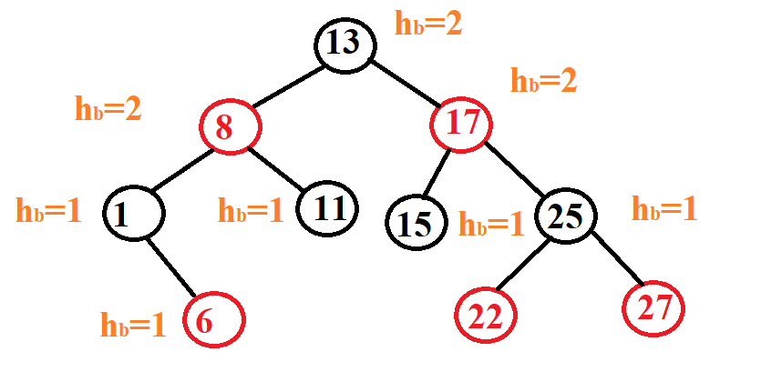

### II. Operations on Red Black Tree

* How to declare node in RB tree:

#define RED 1

#define BLACK 0

typedef bool colour;

struct node

{

node *parent,*left,*right;

int key;

colour color;

};

#define NIL &sentinel /* all leafs are sentinels */

node sentinel = {NIL,NIL, NIL, 0, BLACK};

-Insert a new element:

+The inserted node is always red because then our rule number 5 will not be normalized but agree that rule number 4 can be violated but then it will be easier for us to modify the tree.

+We also do the same as the BST tree in the first step, find the insertion location.

+The next step we will check to see if it is in any of the cases after inserting:

. If the parent node is Black => it doesn't matter.

. If the parent node is Red => violates parent-child are Red => adjust to balance tree. The tree correction here only takes place when there are 2 consecutive red nodes, not like the AVL tree, which has to check the length of 2 subtrees of the node. After done, if the tree meets the equilibrium condition, then it is correct.



Before going into how to edit the tree, let's talk about rotation in RB Tree. Basically, the rotation is no different from the rotation of a node in AVL, but in the code we have to modify the parent node of that node because then the parent node of that node is already connected to the child node of the rotated node.



+ How to edit a tree when the parent node is a red node: The algorithms have mainly two cases.

. If the uncle is red, we do recolour.

. If the uncle is black, we do rotations and /or recolouring.

*Note:* uncle is the same node as the parent node of the node under consideration.

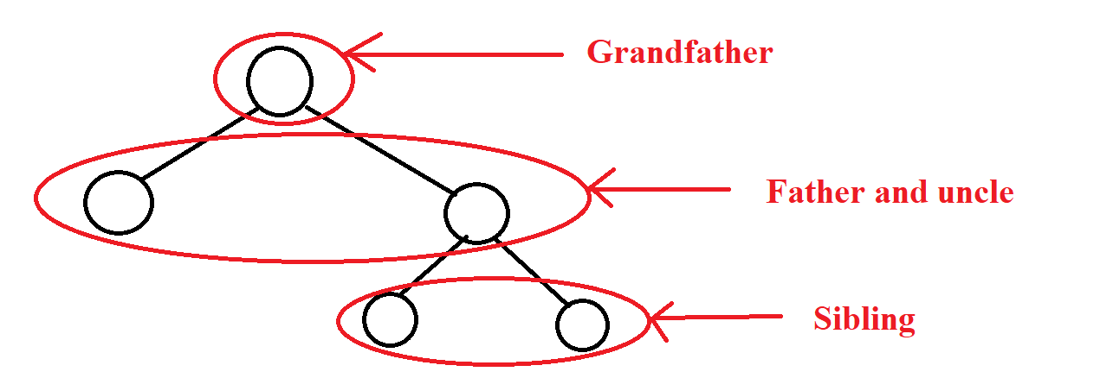

We list 6 smaller cases for easy control. But we only need to find the first 3 cases where the newly inserted node is located in the left subtree of the grandfather node and the last 3 cases do the same as above but only differ in direction.

***Case 1****:* If the parent node is red, the uncle is red, then we only need to change the color of the parent node, uncle and grandfather node. But notice that if he is a root node, we won't change the color but keep it black.

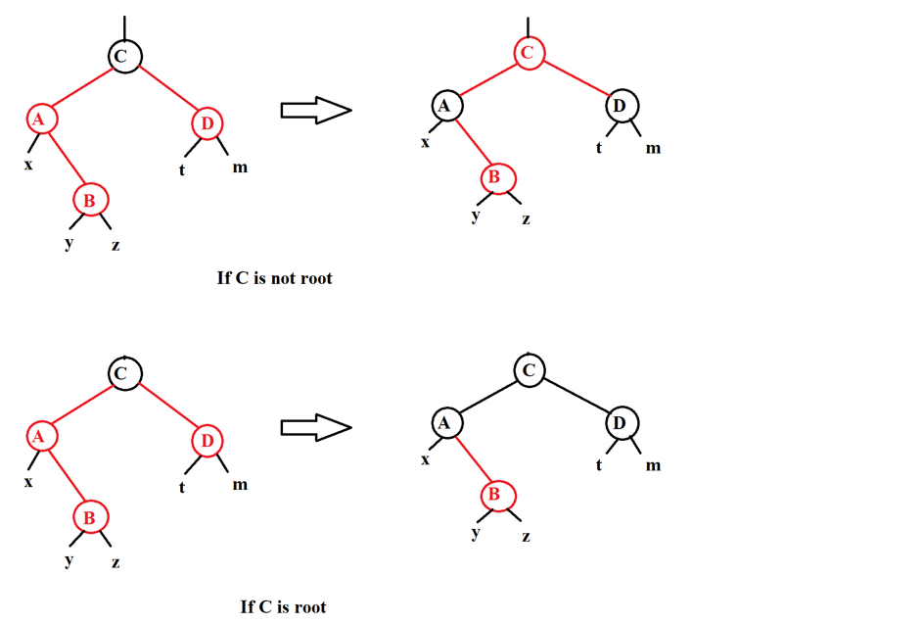

***Case 2****:* If the parent node is red, the uncle is black and the inserted node is the left child of the parent node, we change the color of the parent node and the grandfather node, then we will rotate right at the grandfather node.

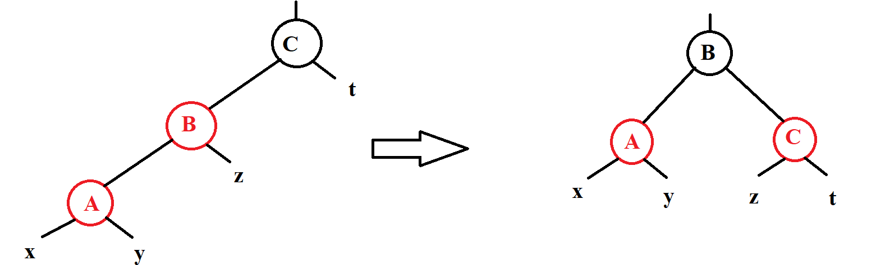

***Case 3****:* If the red parent node, the black uncle node and the newly inserted node are the right child nodes of the parent node, then we take the parent node to turn left and right rotate the grandfather node. Finally, we change the color of the parent node and the grandfather node.

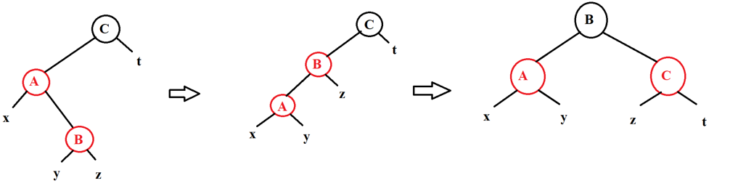

***Case 4, Case 5, Case 6****:* We also do the same operation as above, but only in the opposite direction, this time the node is added it is in the right subtree of his node.

+ At the last step of the insert, we just do the same as the AVL tree, which is to go against the above nodes that have been approved to see if there is a violation of the attribute of 2 consecutive red nodes.





Example: Add 7, 3, 18, 10, 22, 8, 11, 26, 2, 6, 13

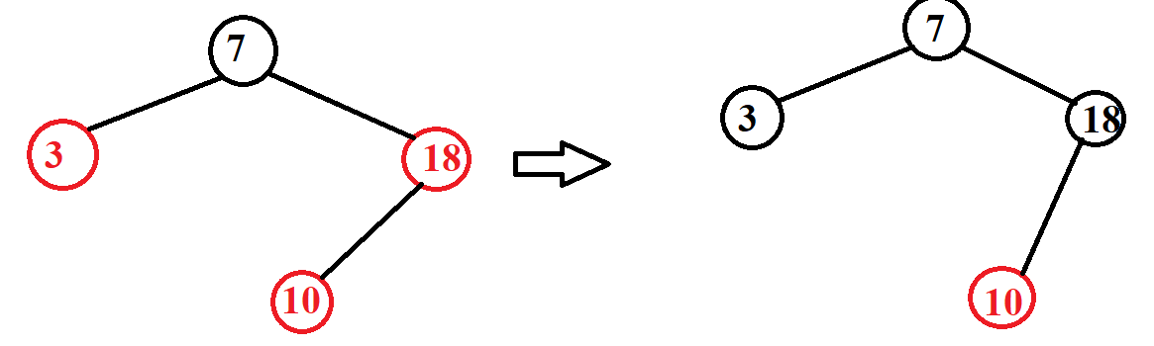

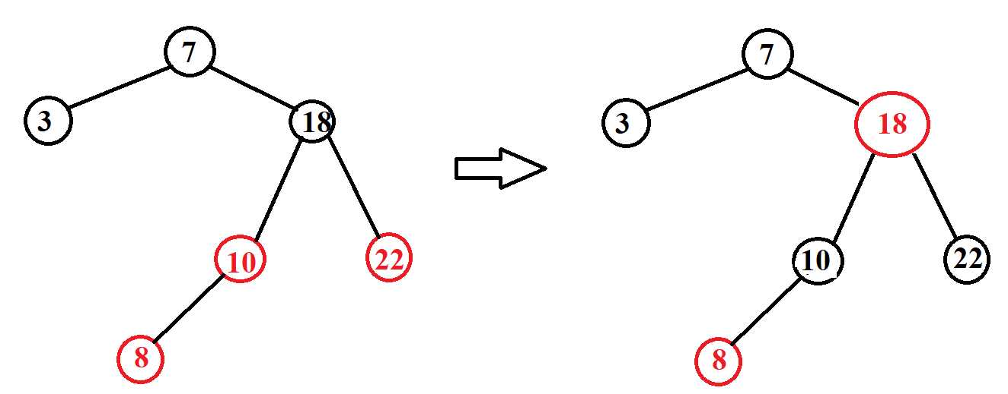

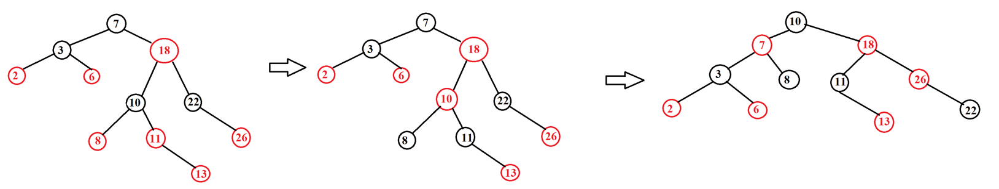

-Delete an element:

+The first step we do the same as BST is to find and delete the node to be deleted. Note when in the case of deleting node 2 children, we only replace the lice without changing the color.

+Just like inserting we also have 2 cases:

. The actually deleted node is the red node. In this case, we just need to delete the node normally or in other words, treat it as a BST tree to delete. Because it doesn't violate any rules in the RB tree.

. The actually deleted node is the black node. This is the most difficult case because deleting it will cause many cases of violating the rules of the tree. For example, we will be able to make the root node turn red because it can delete root and replace it with a red node. It may violate the rule that 2 consecutive child nodes cannot be red because deleting that node may cause the child node and parent node of the deleted node to be red and connected. Finally, we can change the number of black nodes of a node to the NIL node because deleting can reduce the black node.

+As mentioned above, the case of deleting a black node is the most difficult case we need to consider.

. After finding the node that needs to be deleted, we don't need to delete it, but we have to do an action called removing that node from the tree. That is, if the node is less than 2 children, then we connect the parent node with the child and then we will edit the tree immediately the child node of the node is deleted, and in the case of deleting a node with 2 child nodes, we will immediately deal with the child node at the node whose replacement price is taken.

. After editing the tree, we will delete the node to delete.





*There are 2 cases in case of deleting the black node:

***Case 1****:* The child of the delete black node is in red: we just need to change the color of child node to black.

***Case 2****:* the child of the deleted black node is in black: we will do the steps below(We only need to consider the case that the node to be deleted is in the left subtree of its parent node, in the other case we do the same but only do the opposite.) We will call the node that is deleted as node n, the sibling node as node s and the parent node is p.

* Step 1: If n has no parent (n is the root): end. Otherwise we go to step 2.
* Step 2: n is black, s is red.

-We change color and rotate left at parent node.

-We change the color of node p.

-Go to step 3.

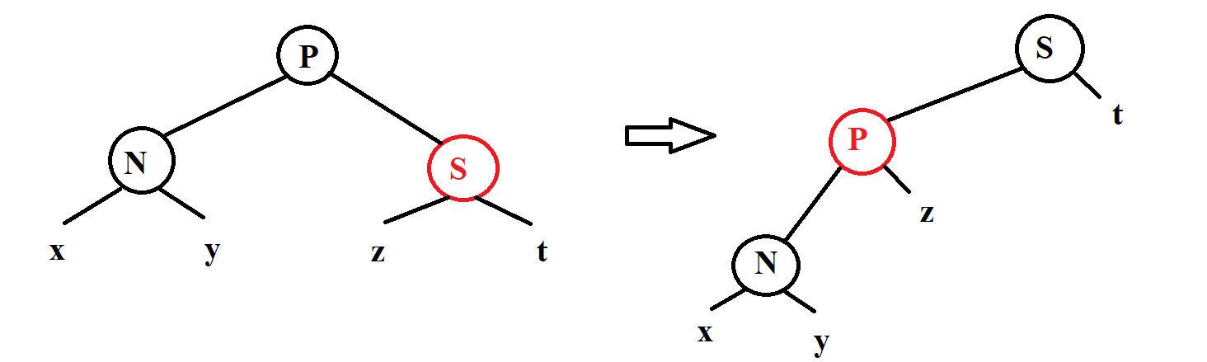

* Step 3: n is black, s is black, children of s are black, p is black.

-Change node s color to red.

-Go back to step 1 with n being its parent node.

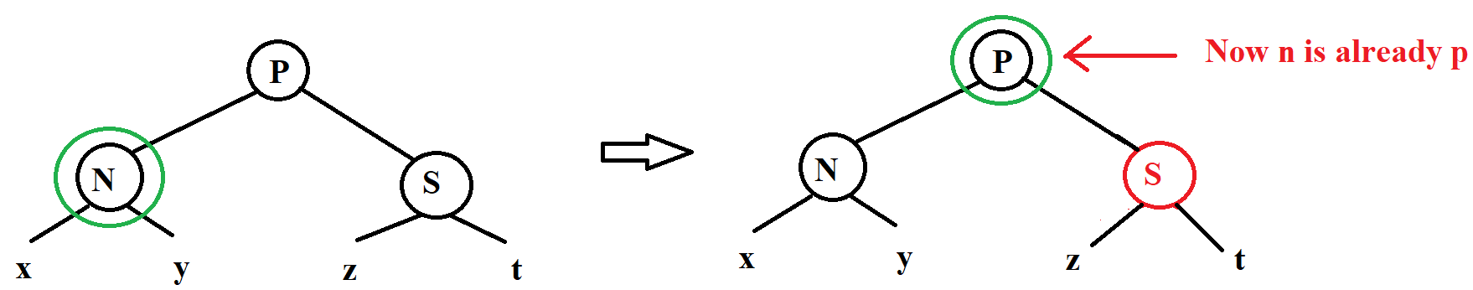

* Step 4: n is black, s is black, children of s is black, p is red.

-Change node p to black and node s to red.

-End the process of editing the tree when deleting here. Otherwise, if we do not fall into this step, we will go to step 5.

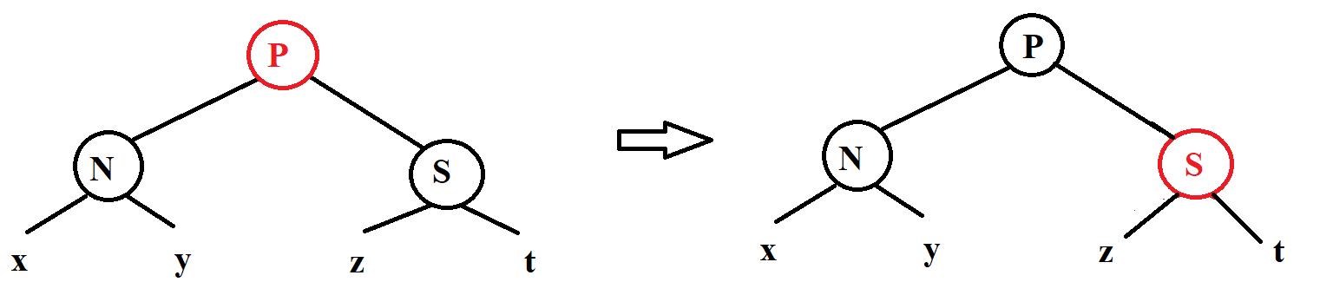

* Step 5: n is black, s is black, left child of s is red, right child of s is black.

-We change the color of node s and the left child of node s.

-We turn right at node s.

-Go to step 6.



* Step 6: n is black, s is black, right child of s is red.

-We change the color of node p and s for each other.

-We change the color of the right child node of node s to black.

-Turn left at node p.

-We end the tree editing process here.

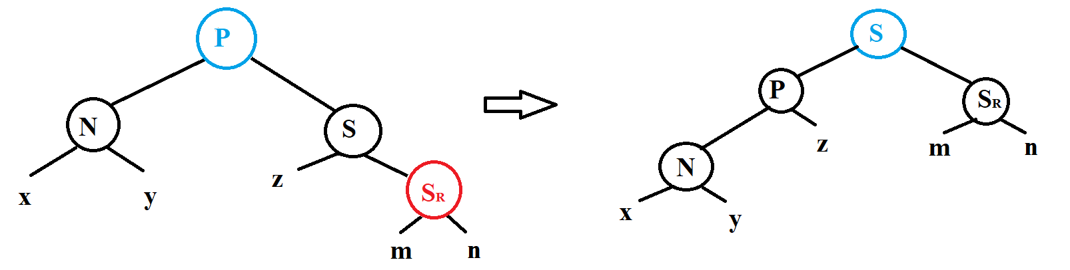

 

Example: We have an RB tree 7, 3, 18, 10, 22, 8, 11, 26, 2, 6, 13. We will delete the elements 18, 11.

+Delete 18:

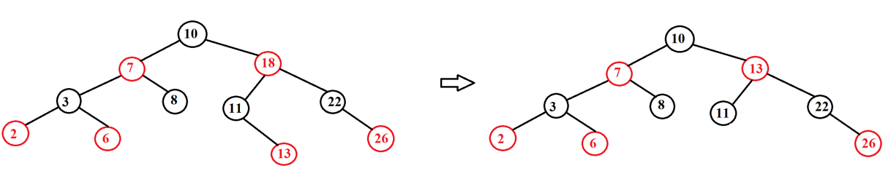

+Delete 11

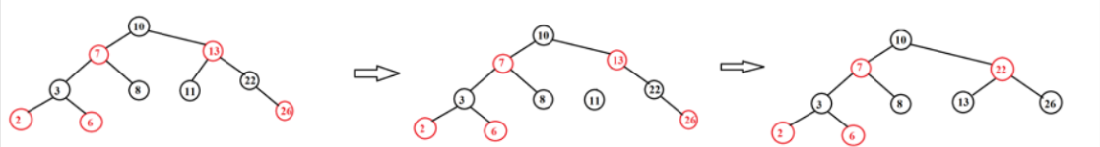

-Complexity and tree height:

+ Complexity:

. Search O($\log_{2}{N}$)

. Insert O($\log_{2}{N}$)

. Delete O($\log_{2}{N}$)

. Minimum O($\log_{2}{N}$)

. Maximum O($\log_{2}{N}$)

### III. Illustration examples

*Example 1:*

* **INPUT:**

-Insert:32, 20, 10, 15, 40, 25, 27, 26, 13, 14.

-Find: 15, 29

-Delete: 25, 40, 20

* **OUTPUT:**

-Insert:

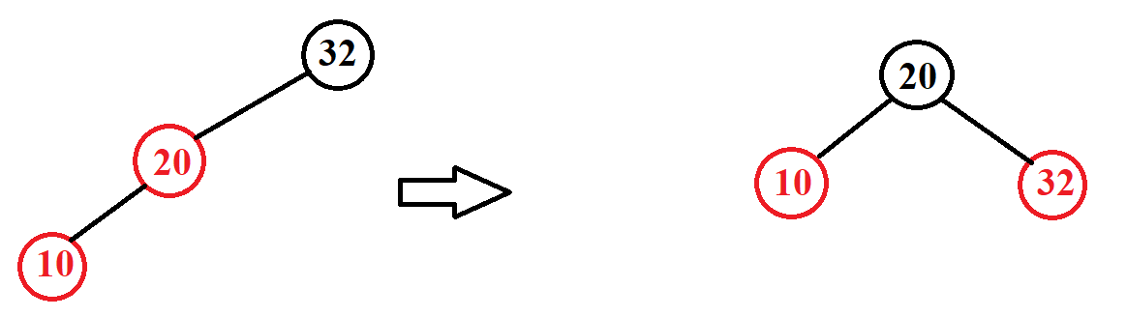

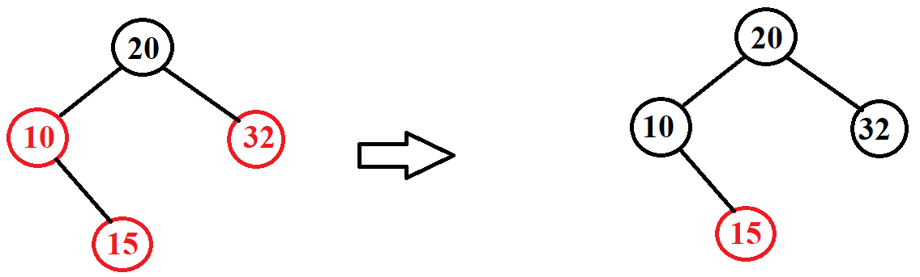

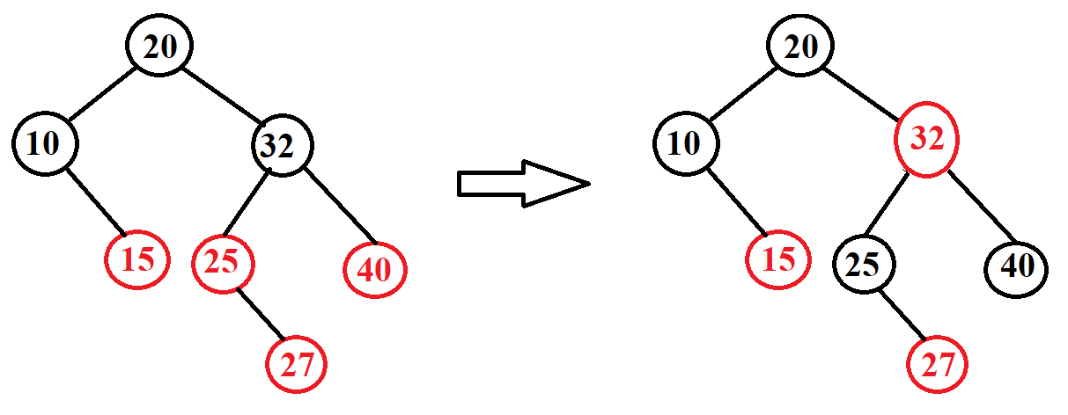

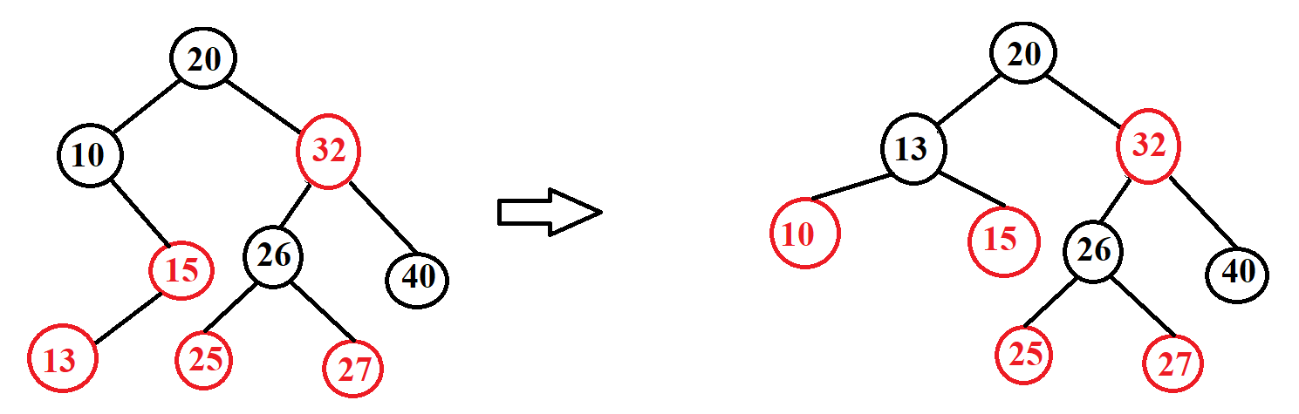

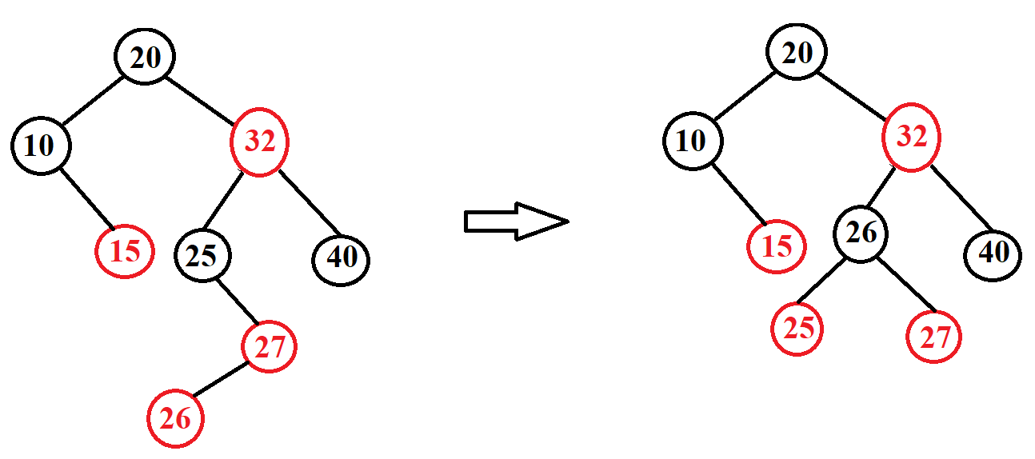

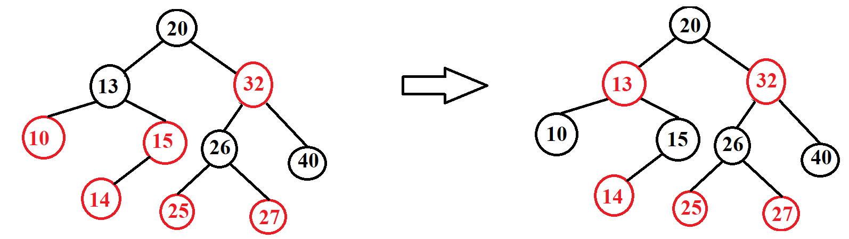

-Find:

+Find 15

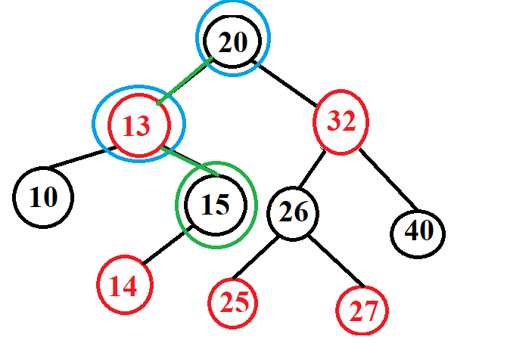

+Find 29

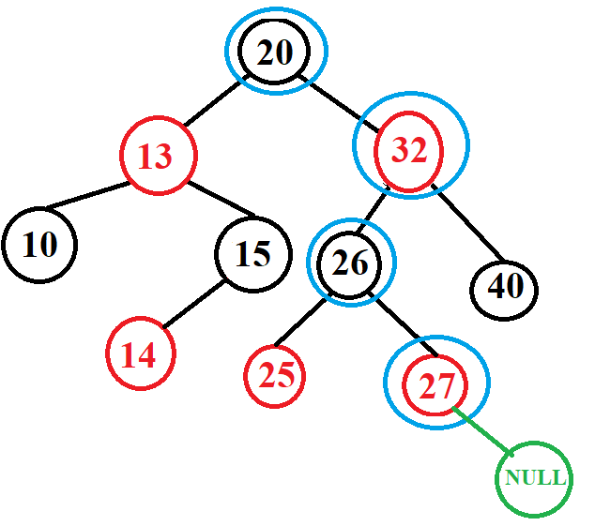

-Delete:

+Delete 25.

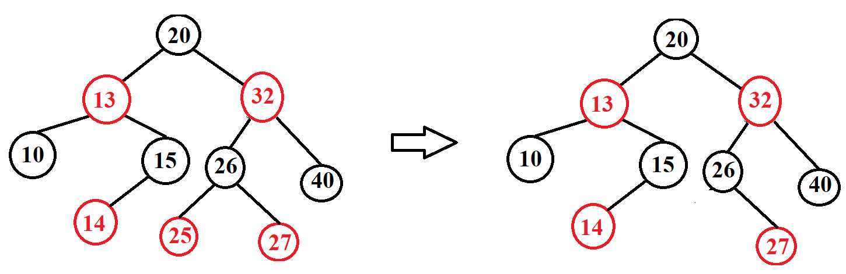

+Delete 40.

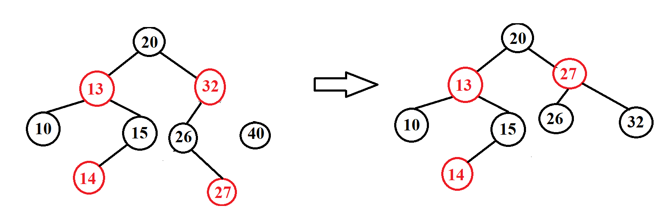

+Delete 20.

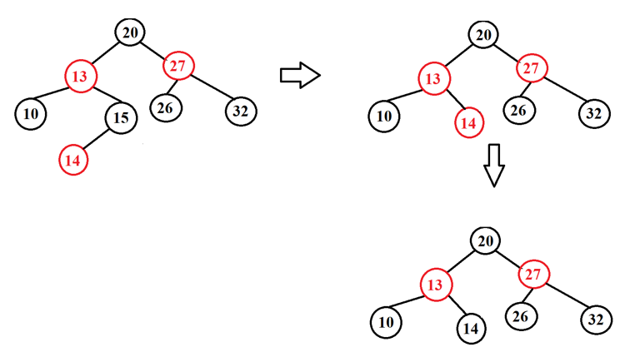

*Example 2:*

* **INPUT:**

-Insert: G, J, A, T, B, W, C, K.

-Find: A, Z

-Delete: J, A

* **OUTPUT:**

-Insert:

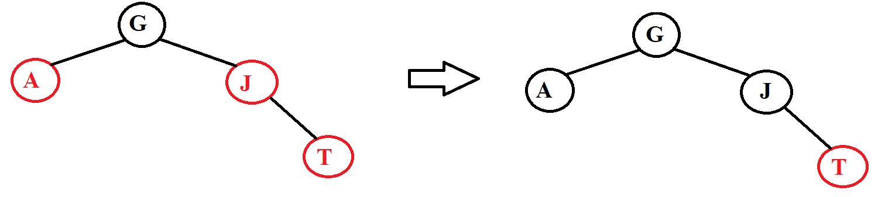

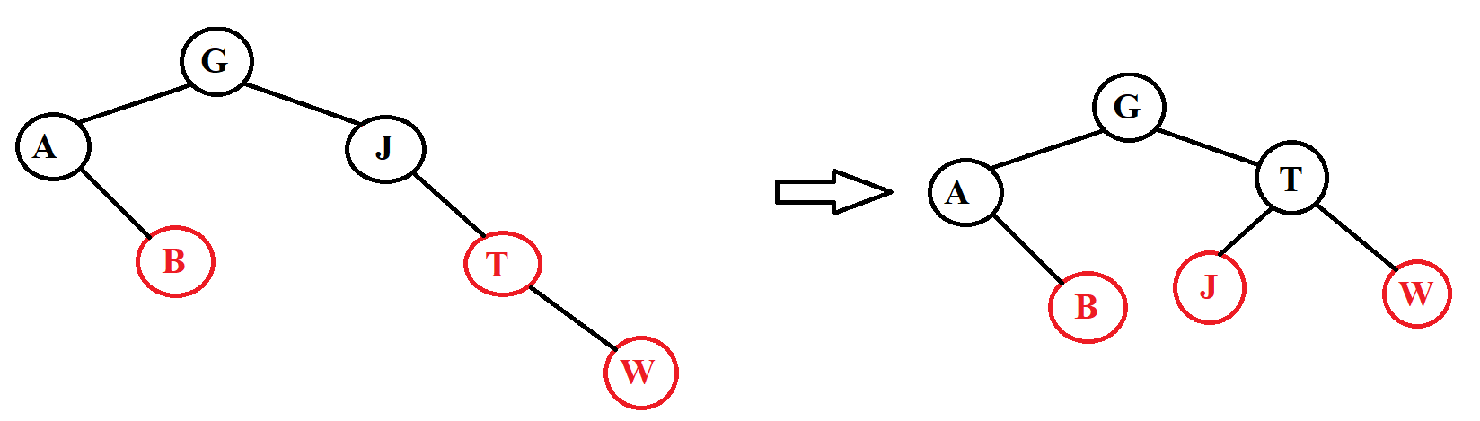

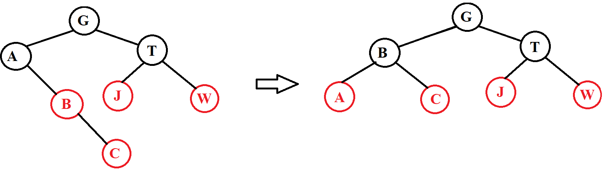



-Find:

+Find A

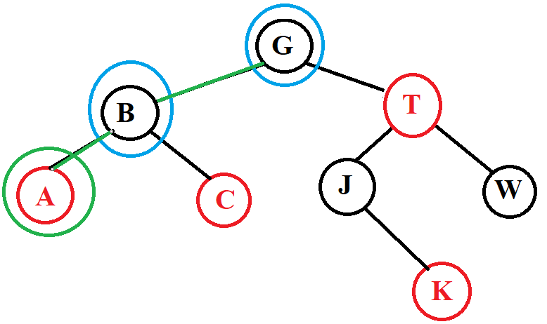

+Find Z

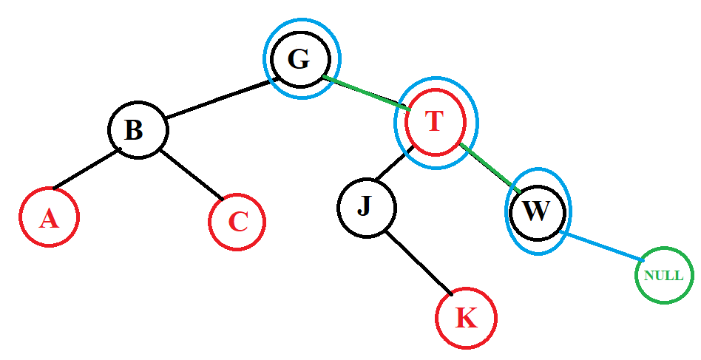

-Delete:

+Delete J:

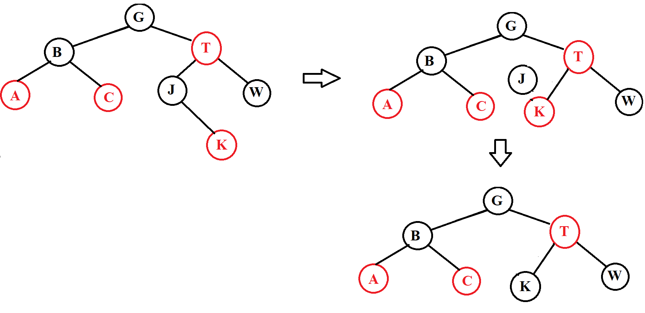

+Delete A

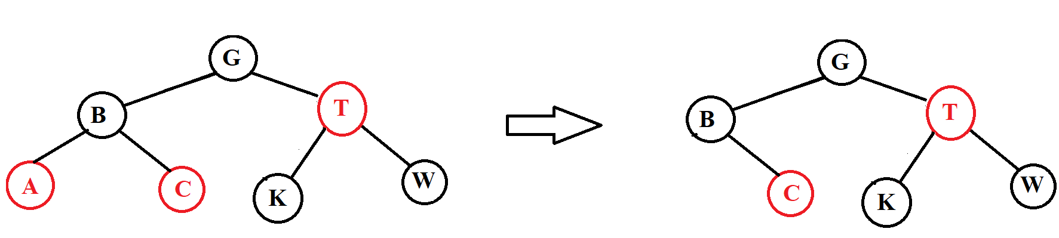

*Example 3:*

* **INPUT:** input is a data pair of the form (x,y) where x is an integer and y is a letter. We will compare the number first if the number is equal, we compare the letter.

**-**Insert: (5,g), (4,b), (5,a), (9,e), (2,p), (1,z)

**-**Find: (9,e), (7,a)

**-**Delete: (5,g), (2,p)

* **OUTPUT:**

-Insert:

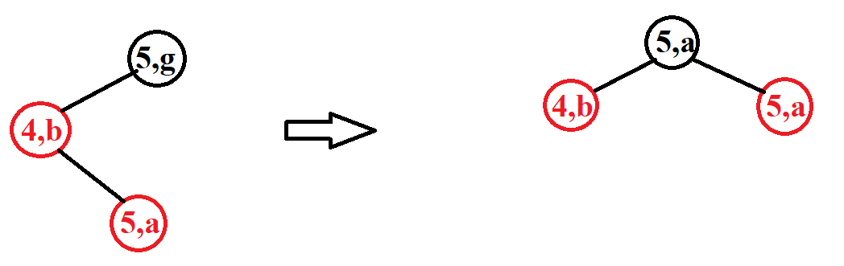

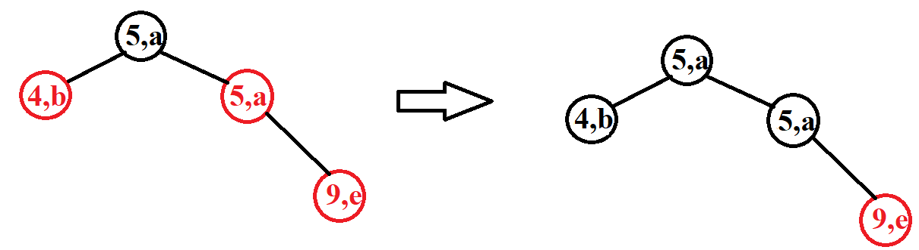

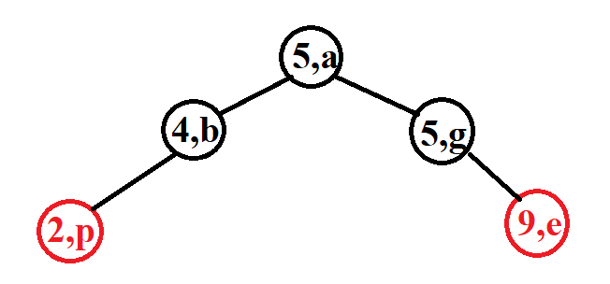

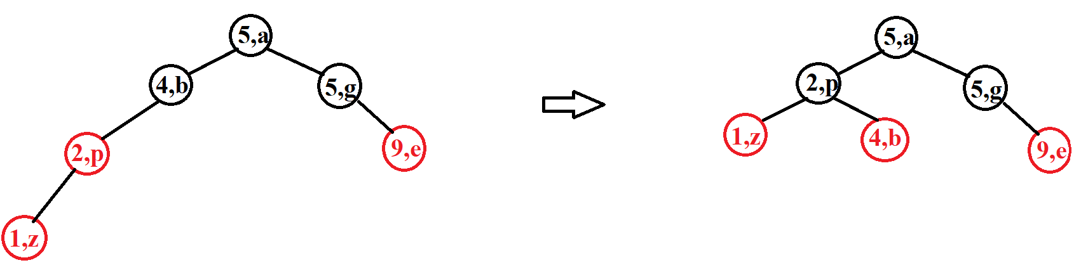

-Find:

+Find (9,e)

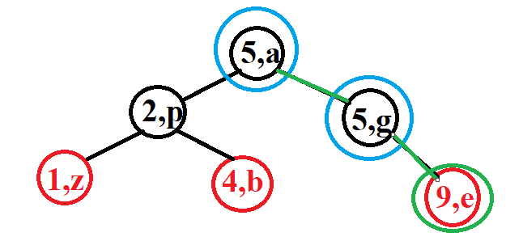

+Find (7,e)

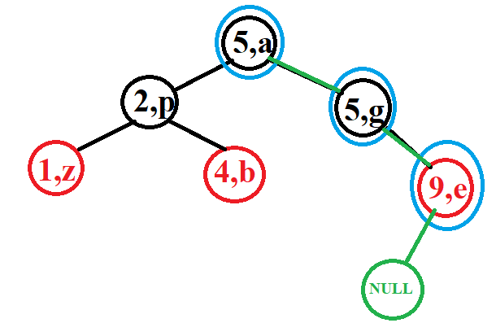

-Delete:

+Delete (5,g)

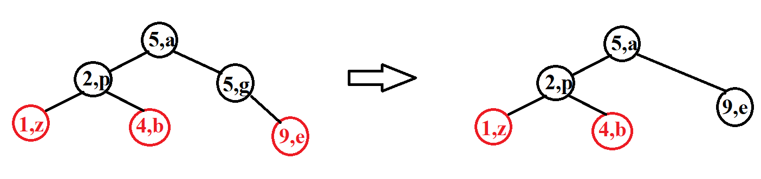

+Delete (2,p)

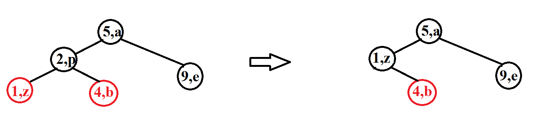

### IV. Compare AVL and RB tree:

- Search operations of AVL trees are faster than those of RB trees because they are more tightly balanced. Because it checks for it to correct the tree occurs with more frequency than AVL, for example in insert we see it will check 2 child nodes in a row so it will rotate more, leading to a tighter equalization tree.

- Red-black tree has faster insertion and deletion than AVL tree because RB tree has a tighter balance, so those two operations make RB tree faster than AVL.

- Storing in 1 node of AVL tree is less than RB tree because it will store 1 more data which is color.

- the rotations for an AVL tree are harder to implement and debug than that for a Red-Black tree.

- Red Black Trees are used in most of the language libraries like map, multimap, multiset in C++.

**\*Reference source:**

**-**Geeksforgeeks.

-kc97ble.

-Lesson Slides.